Press Facts
Manufacturing of rolls for the steel industry
Heinrich Georg Maschinenfabrik:
Two machines, one operator
Linking two roll lathes doubles capacity without increasing personnel costs
Kreuztal, Germany, 6 Mai 2019 Heinrich Georg Maschinenfabrik has received an order from Vítkovické Slévárny, spol. s r.o. for the supply of a roll lathe, the third lathe so far supplied by GEORG to the Czech roll manufacturer. The new machine will be linked with one of the existing lathes. Thanks to this solution, only one operator will be needed to control both machines.
With the new machine, Vítkovické Slévárny will expand the capacity of its facilities in Ostrava, where two other GEORG roll lathes of the ultraturn series have already been in operation for several years.
The new machine will be virtually of the same design as the machine supplied in 2013. However, a novelty is its connectivity with the existing lathe, which will allow both machines to be operated by just one person. Among others, the two machines will be equipped with cameras and monitors for the operator to be able to control both of them permanently and simultaneously.
Tomasz Dolba, Manager of the Ostrava roll shop, explains his investment decision: “We manufacture rolls for section and strip rolling mills. The lathes we need for our machining tasks must be extremely flexible because we use them for both rough machining and high-precision finish machining. The hydrostatic guideways of the machine beds in our GEORG lathes have proved very successful in two respects: thanks to the low wear of the equipment, the machines retain their accuracy over a very long period of time and that provides us a clear cost advantage.”
The now ordered ultraturn lathe will be designed to machine up to 8,000-mm-long rolls with diameters of up to 1,550 mm and roll weights of up to 30 t. The 170 kW main drive achieves a maximum torque of 70,000 Nm. Like the two earlier machines, GEORG will also supply the new machine complete with a dust extraction system and a cabin that protects the operator against flying metal chips. This provides a maximum of work safety and optimal ergonomics.
According to Jan Ebener, Head of Sales at GEORG´s machine tools division, the recent order confirms GEORG’s strategy towards deeper interlinking of production processes. “The new machine is an exact twin of the one we last supplied to Ostrava. This shows us that the customer is satisfied with the quality and reliability of the previously supplied machines in every respect. By interlinking both machines, we take efficiency to the next level: our customer receives double the capacity without extra personnel costs.”
Supply of the new machine is scheduled for the summer of 2020.
430 words including the introduction
About Heinrich GEORG Maschinenfabrik
GEORG is a worldwide well-reputed partner for reliable and powerful high-tech engineering and process optimization solutions. The company’s cutting-edge finishing lines and machine tools as well as production lines, machines and equipment for the transformer industry are in operation in numerous renowned companies around the world.
With its encompassing product and service offers and its worldwide network of sales and service branches, the family-owned company, which employs almost 500 people and is now in its third generation, caters to markets as challenging as energy, mobility and industrial.
For more information please visit www.georg.com
Contact:  Heinrich Georg GmbH Maschinenfabrik  Thomas Kleb  Leiter Marketing & Kommunikation  Langenauer Straße 12  D-57223 Kreuztal/Germany  Fon: +49.2732.779-539  Fax: +49.2732.779-39171  www.georg.com  Email: thomas.kleb@georg.com | Press contact:  VIP Kommunikation  Dr.-Ing. Uwe Stein  Dennewartstraße 25-27  D-52068 Aachen/Germany  Fon: +49.241.89468-55  Fax: +49.241.89468-44  www.vip-kommunikation.de  Email: stein@vip-kommunikation.de
Figures and captions
High-resolution image files are available for downloading at:
press photos Heinrich Georg
Fig. 1a: The new lathe will be designed to machine up to 8,000-mm-long rolls with diameters of up to 1,500 mm and roll weights of up to 30 t. Shown in the photo is the machine of identical design supplied in 2013.  File name:  Georg 4252 Gesamtmaschine_07 .jpg | 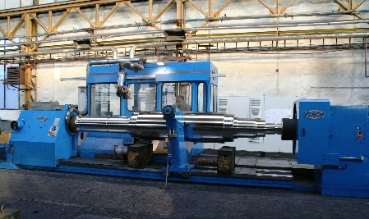
Fig. 1b: The new lathe will be designed to machine up to 8,000-mm-long rolls with diameters of up to 1,500 mm and roll weights of up to 30 t. Shown in the photo is the machine of identical design supplied in 2013.  File name:  Georg 4252 Gesamtmaschine_06 .jpg | 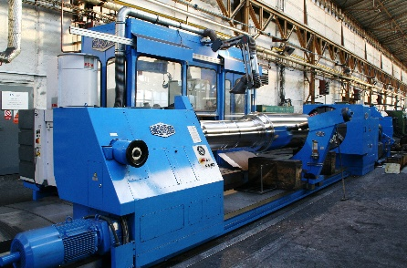
Photos provided by Heinrich Georg Maschinenfabrik

