Strip processing in aluminium rolling mill
Heinrich GEORG Maschinenfabrik:
New high-speed side-trimming line for Elval
Kreuztal, Germany, 8 April 2024 In October 2023, ElvalHalcor Hellenic Copper and Aluminium Industry S. A. commissioned a new high-speed side-trimming line for aluminium strip. Designed to operate at strip speeds of up to 1,650 m/min, the new trimming line is one of the fastest of its kind in the world.
The new line for Elval’s Oinofyta works in Greece was supplied by GEORG on a turnkey basis. The supply range comprised all systems from the payoff reel up to the transfer of the coil to the packaging area. The line is used to side-cut up to 2,100-mm-wide aluminium strip of grades 2XXX to 5XXX.
The line operates virtually fully automatically: It receives all parameters such as width, thickness and alloy of each coil to be processed from the works MES. Based on these data, the line control system adjusts the cutting depth of the blades and the cutting gap width. By optimizing the processes in all plant areas, very short coil-to-coil times are achieved, enabling annual throughputs of more than 400,000 t.
To prepare the coils for the trimming process, an inline drum-type shear crops the coil ends at strip speeds of up to 200 m/min. The high precision and repetition accuracy with which the side-cutting blade is adjusted achieves a cutting accuracy distinctly superior to that required by the DIN EN 485 standard. Due to the exceptionally high line speed, the trimmings are cleaned by a suction system and automatically wound on a scrap winder.
The spraying width of the electrostatic oiling system automatically adjusts to the respective strip width, avoiding excessive oil accumulation on the edge zone. Suction systems arranged along the line ensure that oil droplets coming off the strip surface due to the high line speed are reliably removed. A manipulator fits and centers the empty sleeves on the recoiler mandrel. The coil head-ends are automatically bonded to the sleeves.
GEORG supplied the line complete with a wide range of measuring and inspection systems such as a thickness measuring system, a pinhole detection device and a surface inspection system.
Detlef Neumann, Sales Manager Finishing Lines at GEORG, commenting on this successful project: “In the global aluminium industry, there is just a handful of trimming lines operating reliably at such high speed. Therefore, we are very happy and proud that our customer has issued the FAC after a very short test run and that the line has been operating highly efficiently ever since.”
420 words including introduction
Contact at GEORG:  Heinrich GEORG GmbH Maschinenfabrik  Thomas Kleb  Head of Marketing  Langenauer Straße 12  D-57223 Kreuztal/Germany  Phone: +49 2732 779-539  E-mail: thomas.kleb@georg.com  www.georg.com | Contact for the media:  VIP Kommunikation  Dr.-Ing. Uwe Stein  Dennewartstraße 25-27  D-52068 Aachen/Germany  Phone: +49 241 89468-55  www.vip-kommunikation.de  E-mail: stein@vip-kommunikation.de

Figures and captions
Download: press photos GEORG

Fig. 1: The coils to be side trimmed are produced in the new six-high mill.  File name:  GEORG_IMG_1173.jpg | 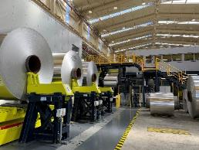
Fig. 2: The entry section viewed from the downcoiler. A wide range of measuring systems assure the high quality of the finished coils.  File name:  GEORG_IMG_20230524_153637.jpg | 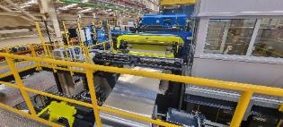
Fig. 3: The entry section viewed from the downcoiler. A wide range of measuring systems assure the high quality of the finished coils.  File name:  GEORG_IMG_20230524_153637_a.jpg | 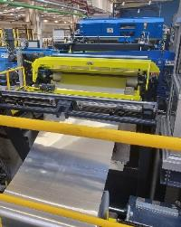
Fig. 4: Control room of the trimming line  File name:  GEORG_IMG_0949.jpg | 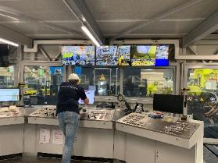
Fig. 5: A perfect coil being recoiled.  File name:  GEORG_IMG_1150.jpg | 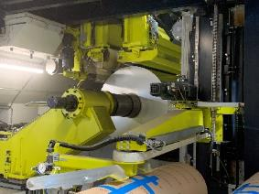
Image rights: Heinrich GEORG Maschinenfabrik
About Heinrich GEORG Maschinenfabrik
GEORG specializes in the design of advanced, cost-efficient solutions for coil processing and roll grinding machines. In its solutions, GEORG combines classical mechanical engineering expertise with smart process optimization and service know-how. The company’s cutting-edge finishing lines, world-leading production equipment for the transformer industry and advanced roll grinding machines are in operation worldwide at leading manufacturers of premium products. There, they make a significant contribution to process optimization and the companies’ business success. There, they make a significant contribution to process optimization and the companies’ business success. Machines and systems from GEORG are noted for their high level of automation and used in both highly customized and standard applications. The portfolio is complemented by a broad range of services, including consultation, engineering and maintenance.
The family-owned company, which has more than 500 employees, is now in its third generation. Via its global network of sales and service offices, GEORG supplies its products to key markets, including energy, mobility, and manufacturing. GEORG observes the principles of sustainability, resource saving and energy efficiency.
For more information please visit georg.com

