Press facts for FIEE 2019
Cutting and stacking of transformer cores
Heinrich GEORG:
Inline and offline stacking systems use the potential of digitalization
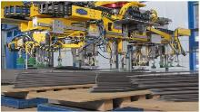
Kreuztal, Germany, June 7, 2019 At FIEE 2019, Heinrich GEORG is going to present its new inline cutting and stacking line of the GEORG precisioncut TBA400 robotline series and its offline stacking system of the autostack series. With these new systems GEORG rounds out its range of cutting and stacking equipment for transformer sheets with systems of different degrees of automation: Besides the proven ecoline systems, GEORG now also offers highly automated equipment that use the potential of modern articulated robots and advanced handling systems.
Inline system: TBA400 robotline
The GEORG precisioncut TBA400 robotline can automatically cut and stack up to eight closed or open distribution transformer cores at the same time. The plants are designed for deep integration into the customers’ data infrastructure. Functionalities like the GEORG coreeditor enable highest degrees of automation in the production of transformer cores. Additionally, it supports various kinds of core handling logistics.
Offline systems: Autostack technology
The newly developed GEORG autostack 400 is an offline system for the automatic stacking of distribution transformer cores. The system was developed in cooperation with GÜDEL Group AG from Switzerland. This highly automated system interfaces with GEORG core cutting lines and features an integrated data management system. The direct data transfer between the cutting line and the robot makes time-consuming manual process superfluous. Thanks to this data link, the new system can be easily integrated into the digital network of the production plant.
Bernd Peter Schmidt, manager of GEORG’s transformer line division, is convinced that the expanded product range will cater to the requirements of the South American markets: “Now our customers can choose between systems of different degrees of automation. All our equipment has one thing in common: We supply complete integrated solutions ... down to autonomous, driver-less transport platforms for internal works logistics.”
300 words including the introduction
Heinrich GEORG at FIEE 2019
International Electric, Electronic, Power and Automation Industry Exhibition
São Paulo Expo, Brazil, July 23 – 26, 2019
Booth D144

About Heinrich GEORG Maschinenfabrik
GEORG is a worldwide well-reputed partner for reliable and powerful high-tech engineering and process optimization solutions. The company’s cutting-edge finishing lines and machine tools as well as production lines, machines and equipment for the transformer industry are in operation in numerous renowned companies around the world.
With its encompassing product and service offers and its worldwide network of sales and service branches, the family-owned company, which employs almost 500 people and is now in its third generation, caters to markets as challenging as energy, mobility and industrial.
For more information please visit georg.com
Contact:  Heinrich GEORG GmbH Maschinenfabrik  Thomas Kleb  Leiter Marketing & Kommunikation  Langenauer Straße 12  D-57223 Kreuztal/Germany  Fon: +49.2732.779-539  Fax: +49.2732.779-39171  www.georg.com  Email: thomas.kleb@georg.com | Press contact:  VIP Kommunikation  Die Content-Agentur für Technik-Themen  Dr.-Ing. Uwe Stein  Dennewartstraße 25-27  D- 52068 Aachen/Germany  Fon: +49.241.89468-55  Fax: +49.241.89468-44  www.vip-kommunikation.de  stein@vip-kommunikation.de
Figures and captions
High-resolution image files are available for downloading at:
Pressefotos Heinrich Georg
Figure 1: The new GEORG autostack 400 is an offline system for automatic stacking of cores for distribution transformers.  File name:  GEORG_Autostack_400_1.jpg | 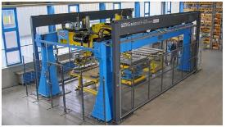
Figure 2: The gripper arm of the GEORG autostack 400 for lifting and precise stacking of transformer core sheets.  File name:  GEORG_Autostack_400_2.jpg | 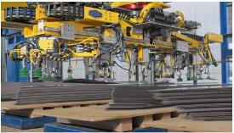
Figure 3: The GEORG precisioncut TBA400 robotline system is designed to automatically cut and stack up to eight closed or open distribution transformer cores at the same time.  File name: GEORG_TBA_400_robotline_1.JPG.jpg | 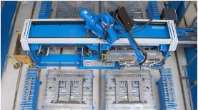
Photos provided by Heinrich GEORG Maschinenfabrik

