Press Facts
Roll grinders
New machine concept combines optimum surface quality with minimum assembly time
“Ex stock”-supplied roll grinder achieves excellent results at AMAG.
Kreuztal, Germany, 26 November 2020 Heinrich Georg Maschinenfabrik has recently commissioned a roll grinder at AMAG, based in Ranshofen, Austria. This is the very first roll grinder featuring the new ultrablock machine bed designed by GEORG. Thanks to this design, the machine can be assembled and installed at the customer’s site in much less time. At the same time, the high grinding precision of the machine ensures that AMAG’s extremely exacting requirements on the surface quality of its produced strips are met at all times.
Increasingly higher demands in terms of strip surface quality was the main reason for AMAG to consider the investment in a new roll grinder. When work rolls used in cold rolling are ground, special care has to be taken to ensure that the surfaces are extremely homogeneously ground. There must be no grinding traces such as shading, or spiral and shatter marks. Equally important is the achievement of utmost geometrical precision of the ground profile and perfect roundness of the rolls.
During the grinding tests at GEORG’s facilities in Kreuztal on rolls from AMAG’s Ransdorf rolling mill, the GEORG ultragrind SG2 met the required specifications right away, without any adjustments to the specifics of aluminium cold rolling. Another decisive factor for AMAG to decide in favour of the GEORG grinder was the new GEORG ultrablock design which allows for extremely short assembly and installation times. The new grinder was put into operation just six weeks from the start of the assembly work. In September 2020, AMAG issued the FAC.
The new GEORG ultrablock design
In the past, roll grinders used to have a machine bed consisting of two separate iron cast beds – one for the roll and one for the supporting structure – mounted on a common foundation block.
In contrast to this, the GEORG ultragrind SG2 comes with an entirely new machine bed design: the machine bed is made in UHPC (ultra high-performance concrete) with the guiding rails being embedded during the concrete casting process. Thus the machine bed is inherently stable, providing the highest possible grinding precision. Moreover, this design significantly reduces the time needed for assembling and commissioning the machine.
Another advantage of this machine design is that it requires extremely little maintenance. The specially designed, self-cleaning guiding tracks, for example, guarantee many years of low-maintenance operation. Additionally, the use of direct drives instead of ball roller spindles reduces the number of components requiring maintenance even further.
Herbert Geier, Project Manager at AMAG: “We favoured the GEORG ultrablock concept because it requires much less foundation work than other grinders. No modifications had to be made to the standard machine. Therefore we also benefited from a very short delivery time.”
Dr.-Ing. Wieland Klein, Head of Technology & Production at GEORG, sees this as a confirmation of the company’s aspiration to always deliver the best quality: “In the production of sheet for car body shells, profit or loss depend on the surface quality of the work rolls, especially in cold rolling, as this is the last shaping stage of the final product before shipment. The project for AMAG has once again proved that not only our customized high-end solutions live up to expectations, but also our medium-segment standardized machines – right away without any modifications.”
The technology in detail
The GEORG ultragrind SG 2 is designed for grinding rolls with diameters of up to 500 mm and lengths of up to 5,000 mm. It can handle roll weights of up to 5 t. The machine can also grind different types of circular blades for cut-to-length lines.
The integrated three-point sensor gauge measures the geometry and the position of the rolls with highest precision. Soft loaders contribute to high safety of operation, preventing any damage to the machine or the rolls during loading and unloading. Machine operation is monitored from a control room, for which a complete satellite operating station has been installed.
675 words including the introduction
About Heinrich GEORG Maschinenfabrik
GEORG is a worldwide well-reputed partner for reliable and powerful high-tech engineering and process optimization solutions. The company’s cutting-edge finishing lines and machine tools as well as production lines, machines and equipment for the transformer industry are in operation in numerous renowned companies around the world.
With its encompassing product and service offers and its worldwide network of sales and service branches, the family-owned company, which employs more than 500 people and is now in its third generation, supplies its products to markets as challenging as energy, mobility and industrial.
For more information please visit georg.com
Contact:  Heinrich Georg GmbH Maschinenfabrik  Thomas Kleb  Manager Marketing & Communikation  Langenauer Straße 12  57223 Kreuztal/Germany  Fon: +49.2732.779-539  www.georg.com  E-mail: thomas.kleb@georg.com | Press contact:  VIP Kommunikation  Dr.-Ing. Uwe Stein  Dennewartstraße 25-27  52068 Aachen/Germany  Fon: +49.241.89468-55  www.vip-kommunikation.de  E-mail: stein@vip-kommunikation.de

Figures and captions
High-resolution image files are available for downloading at:
press photos Georg

Fig. 1a: The ultragrind SG2 in the Ranshofen roll shop ready for final acceptance  File name:  GEORG_DSC05635-mod.jpg | 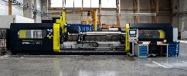
Fig. 1b: The ultragrind SG2 in the Ranshofen roll shop ready for final acceptance  File name:  GEORG_DSC05647-mod.jpg | 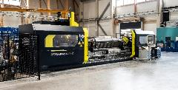
Fig. 2a: The housing provides both highest safety and easy access to the machine.  File name:  GEORG_DSC05627-mod.jpg | 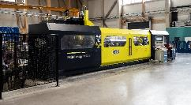
Fig. 2b: The housing provides both highest safety and easy access to the machine.  File name:  GEORG_DSC05619-mod.jpg | 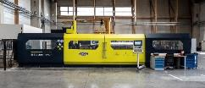
Fig. 3a: The ultragrind SG2 performing grinding tests at the GEORG workshop in Kreuztal on rolls provided by AMAG.  File name:  Georg_DSCN5085.jpg | 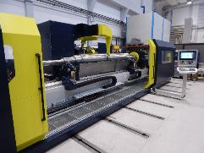
Fig. 3b:The ultragrind SG2 performing grinding tests at the GEORG workshop in Kreuztal on rolls provided by AMAG.  File name:  Georg_DSCN5084.jpg | 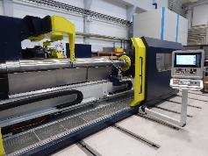
Fig. 4: The integrated three-point sensor gauge measures the geometry and the position of the rolls with highest precision.  File name:  Georg_DSCN5087.jpg | 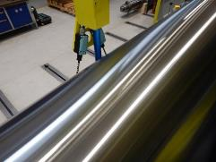
Fig. 5: A sensor lowered from above onto the roll measures the height position of the roll. The information from the gauge facilitates alignment of the roll within the machine.  File name:  Georg_3a.jpg | 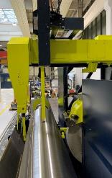
Photo copyright: Heinrich Georg Maschinenfabrik

