Press Facts
High-efficiency descaling
Microline Descaling at Buderus Edelstahl
Buderus Edelstahl invests in new descaling technology
Neunkirchen, Germany, October 7, 2021 Buderus Edelstahl GmbH has placed an order with SGGT Hydraulik for the supply of a Microline Descaling system. The machine, designed for the descaling of semi-finished products, such as billets of different steel grades, is characterized by very short cycle times and high energy efficiency.
Buderus Edelstahl will use the new, type MD 3000, machine for the descaling of up to 140 mm round and square billets with maximum lengths of 400 mm. The descaler’s pressure intensifier will be equipped with SGGT-patented quick-acting nozzle valves, which minimize water consumption. Consequently, the water requirement per part descaled will be below 3 liters.
The up to 320 bar process pressure will be activated only when needed, i.e. when a product is passing through the spraying ring. This makes operation of the machine extremely energy-efficient. The hydraulic output of around 156 kW at the nozzles is achieved with a motor power of only around 15 kW.
Thanks to innovative conveyor and control systems for all related processes – including parts feeding and water filtration –, the machine can descale products within a cross-section range of up to 140 mm and up to 45 kg weight in just 8 s cycle time.
Hot commissioning of the new Microline Descaler is scheduled for January 2022.
200 words

Fig. 1: The SGGT-patented, quick-acting nozzle valves open and release the up to 320 bar pressure only when the system captures a product present within the spraying area.  File name: SGGT_Spritzring_MD_2.jpg | 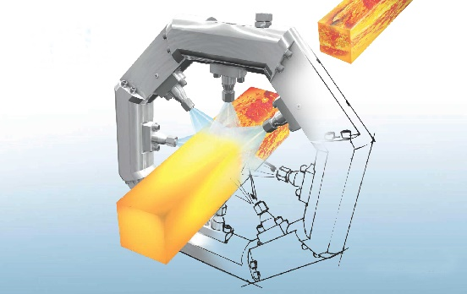
Photos: courtesy SGGT Hydraulik GmbH
About SGGT Hydraulik
SGGT Hydraulik GmbH based in Neunkirchen/Saar, offers system technology and service for descaling and water hydraulics. SGGT equipment is used in the hot forming of metals wherever high pressure is required, often in combination with high flow rates; for example in the steel industry for descaling of slabs, billets and hot strip. The systems are experiencing an increasing demand in the forging industry and in particular in applications where hydraulic descaling was previously not common. The company's customers include renowned forges worldwide. SGGT supplies to many customers directly, and in addition, world-renowned plant engineering companies incorporate SGGT systems in their modern lines.

Contact:  SGGT Hydraulik GmbH  Gregor Przybylla  Betzenhölle 24  D-66538 Neunkirchen/Germany  Fon: +49 6821 92083-20  www.sggt-wh.de  gregor.przybylla@sggt-wh.de | Press contact:  VIP Kommunikation  Dr.-Ing. Uwe Stein  Dennewartstraße 25-27  D-52068 Aachen/Germany  Fon: +49 241 89468-55  www.vip-kommunikation.de  stein@vip-kommunikation.de

