Facts for the trade press
For the Formnext exhibition 2021
The use of the mass finishing technology in additive manufacturing operations

Walther Trowal:
An easy entry into finishing the surface of 3D printed components
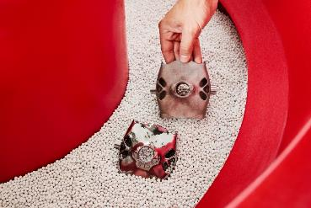
The Walther Trowal AM post process creates perfect surface finishes, even on components with complex shapes.
Haan, Germany, October, 14, 2021 At this year’s Formnext Walther Trowal presents the tub vibrator TRT 83/87 for finishing the surface of 3D printed components. Especially for smaller manufacturing batches this mass finishing machine creates very smooth and shiny surface finishes.
The AM Post Process mass finishing machines were explicitly developed for the post processing of 3D printed components. They are specifically adapted to the surface roughness conditions created by the additive manufacturing process. For example, stair casting, support structure remnants and sintered-on powder residues.
Contrary to electro-chemical treatment systems the AM Post Process creates smooth and shiny finishes on the surface of components with complex, often bionic, shapes in just one or two process stages.
The tub vibrator TRT 83/37, presented by Walther Trowal at the Formnext exhibition, was specifically developed for relatively small manufacturing batches. Generally, one or several work pieces are placed into the processing bowl filled with suitable grinding or polishing media. The vibratory energy induced into the bowl causes not only an intensive rubbing motion, but also creates a considerable pressure between the media and work pieces. Within relatively short cycle times this produces very smooth, homogeneous surface finishes.
Christoph Cruse, sales director at Walther Trowal, considers the TRT 83/87 as an entry-level machine for companies undertaking first steps in the field of additive manufacturing: „Initially, we developed this compact, easy-to-operate machine for cleaning metallic work pieces and are manufacturing it today in relatively large volumes. This allows us offering the machine at a very competitive price. For larger work piece batches that cannot be processed by freely tumbling in the processing media, we offer the rotary vibrator AM 2.“
In the AM 2, specially developed for finishing 3D printed components, the work pieces are mounted to the bottom of the processing bowl. This creates a particularly intensive motion between media and work pieces. Another major benefit of this processing mode is that the firmly mounted work pieces cannot get scratched or nicked by touching each other during the finishing process.
The vibrators of the AM series are equipped with three vibratory motors creating an overlapping motion of the media/work piece mix. This results in a highly homogeneous and gentle grinding/polishing effect of the media on the work pieces. Delicate, thin work piece contours are not breaking off or warping but remain intact. Moreover, the processing media is also finishing difficult-to-reach internal passages and undercuts typical for 3D printed components.
420 words including introduction
Walther Trowal at the Formnext 2021:
Messe Frankfurt/Germany, November 16 – 19, 2021
Hall 12.0, Booth E12
Contact:  Walther Trowal GmbH & Co. KG  Georg Harnau  Rheinische Straße 35-37  42781 Haan, Germany  Tel: +49 2129 571-209  www.walther-trowal.de  g.harnau@walther-trowal.de | Contact for the editor:  VIP Kommunikation  Die Content-Agentur für die komplexen Technik-Themen  Dr.-Ing. Uwe Stein  Dennewartstraße 25-27  52068 Aachen, Germany  Tel: +49 241 89468-55  www.vip-kommunikation.de  stein@vip-kommunikation.de

Photos
Download of the high solution photo files: Pressefotos Walther Trowal
Photo 1: A 3D printed gimbal frame before (top) and after the “Trowalizing” process.
File name:
Walther-Trowal-0921-5692.jpg
Photo 2: A 3D printed blisk segment (top) and after the “Trowalizing” process.  File name:  Walther-Trowal-0921-5684.jpg | 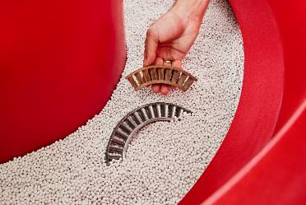
Photo 3: The AM 2 rotary vibrator was specifically developed for finishing the surface of 3D printed components.  File name:  Walther-Trowal-AM-2.jpg | 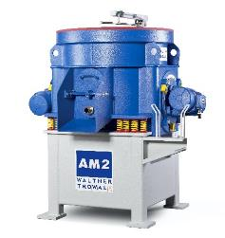
Copyright photos: Walther Trowal

About Walther Trowal
Surface finishing technologies from the inventor of the “Trowalizing” process
Since 1931 Walther Trowal has been developing and producing systems for the refinement of surfaces. Initially focusing exclusively on mass finishing – the term “Trowalizing” originated from the company’s cable address “Trommel Walther” – Walther Trowal has continuously expanded its product portfolio.
Over time the company has developed a broad range of machinery and systems for mass finishing, shot blasting and coating of mass produced small components.
With the invention of new systems like, for example, drag finishing and the development of special finishing methods for 3D printed components, the company has proven its innovative capabilities again and again.
Walther Trowal develops and implements complete surface treatment solutions that can be seamlessly integrated into linked production systems existing at the customers. This includes the entire process technology, perfectly adapted to the specific surface finishing requirements of the work pieces: Equipment and the respective consumables always complement each other in a perfect manner.
Each individual work piece and each manufacturing process must meet special technical requirements. That is why the experienced process engineers in our test lab, in close cooperation with the customers, develop the optimal process technology for the finishing task at hand. The result: Work piece surfaces that meet exactly the required specifications…with short processing times and a high degree of consistent, repeatable results.
Walther Trowal is one of the few manufacturers who develops and produces all machines and mass finishing consumables in-house… including ceramic and plastic grinding and polishing media as well as compounds.
The company’s equipment range also includes all kinds of peripheral equipment for handling the work pieces like lift and tip loaders, conveyor belts and roller conveyors, in addition, special driers for mass finishing applications and, last-but-not-least, systems for cleaning and recycling of the process water.
With its exchange program for wear items like work bowls, which are part of a continuous recycling program, Walther Trowal conserves valuable resources and, thus, makes a significant contribution towards sustainability in the field of industrial production. Quick technical support and the global repair and maintenance service ensure high uptimes for our equipment.
Walther Trowal serves customers in a wide range of different industries all over the world, for example, automotive, aerospace, medical engineering and wind power.

