Facts for the trade press
Mechanical surface treatment with the mass finishing technology
Walther Trowal: Perfect surface finishes for 3D printed components
Mass finishing creates smoothness and luster in one single step
Haan, June 18, 2020 Walther Trowal developed the “AM post process machines”, model range AM, especially for refining the surface of components produced with additive manufacturing. The experience of the first customers using these machines shows that the mass finishing technology creates surface finishes in one single step, which meet the highest demands.
Most 3D printed components are produced by placing material layers on top of each other, creating a “staircasing” effect on their surface with, generally, a very high initial surface roughness. For this reason, many of these components must undergo a surface smoothing or polishing operation. Also, most of the time the markings of removed support structures and sintered-on powder residue must be removed, before the components can be further processed or utilized.
Mass finishing has proven to be the ideal surface finishing method for 3D printed components: These are completely embedded in the moving grinding media so that the process is very gentle and produces absolutely homogeneous and repeatable surface finishes. Moreover, the media also reaches internal passages and undercuts in the components.
The AM post process
Depending on the size of the processing bowl, up to 100 small work pieces or single components with a size of 900 x 500 mm can be treated in the model range AM of the new “multivib” vibrators. The work pieces are mounted on a carrier plate, which in turn is clamped to the bottom of the processing bowl by mechanical or electromagnetic means. Once the work pieces are in place, the media is filled into the processing bowl. During the process compound and water are continuously added. Three vibratory motors induce an intensive vibration into the processing bowl. Since the vibratory movement generated by the motors is overlapping, the component surface becomes smoother, while the edges are left intact. After a pre-determined cycle time the process is completed, and the finished work pieces can be removed.
Several manufacturers of automotive, aircraft and medical components are already using the new AM “multivib” vibrators. These machines reduce the surface roughness of the raw work pieces from around Ra = 2 to 80 µm down to a value of 0.025 µm.
Maximilian Beien, sales manager at Walther Trowal, considers additive manufacturing and mass finishing as a perfect match: “Additive manufacturing and mass finishing are an ideal combination because most 3D printed components must have an excellent surface finish to fulfill their function. For example, turbine blades require an airflow with minimal friction loss. Components with stringent specifications for hardness and strength benefit from the homogeneous peening effect induced by mass finishing. This finishing method is especially advantageous for 3D printed components with bionic shapes.”
Mass finishing is suitable for a wide range of materials utilized in additive manufacturing: For example, for high performance, difficult-to-machine metals like titanium, nickel based or cobalt-chrome alloys. Furthermore, for non-ferrous metals or plastic. With all these materials Walther Trowal has decades of experience.
In this connection it should be noted that the Walther Trowal grinding media and other consumables are already approved for many materials and safety-relevant components and processes.
Beien especially points out the high cost efficiency of the “trowalizing” process in conjunction with additive manufacturing: “Compared to electro-chemical finishing methods mass finishing achieves the desired surface smoothness and luster in one single operation. Another advantage is that the mass finishing equipment is very compact with a small footprint. The result: An excellent surface finish, surprisingly short cycle times and an overall high cost-efficiency, not only with regard to the capital expenditures but also the operating costs.
590 words including introduction
Additional information:
A proven finishing method for an innovative manufacturing technology
Topologically optimized work pieces with complex – frequently bionic – shapes often have difficult-to-reach internal passages. Manual finishing of these surface areas is not possible, especially when the work pieces are subject to strict safety and manufacturing standards, which is the case, for example, in the aerospace industry. Moreover, 3D printing is already used for serial manufacturing with continuously increasing production volumes.
Christoph Cruse, general sales manager at Walther Trowal, looks forward to assist the users of additive manufacturing with their surface finishing challenges: “A lot of things are going on in the field of additive manufacturing. For example, the production process as such must be optimized for many work pieces. For this reason, many customers are very pleased to learn that with regard to finishing the surface of AM components they do not have to invest additional development efforts but can rely on the proven “trowalizing” finishing technology.”
The optimum parameters for the finishing process are, jointly with the customers, determined through processing trials conducted by the process engineers at the Walther Trowal test center. This also includes the selection of the most suitable grinding or polishing media and compound. The process parameters for every single work piece are stored in the PLC and can be retrieved at any time.
Based on his many years of experience with all kinds of projects, Michael Becker, the manager of the Walther Trowal test center, gladly shares his knowledge: „Compared to other finishing systems the single stage process facilitates and shortens the surface finishing operation significantly. Of course, the finishing operation can be further optimized, when all surface treatment considerations are already taken into account during the design phase for the 3D printed components and the parameterization of the printer. For example, this applies to determining the material layer thickness and the material feed rate of the printer. We gladly support our customers in resolving these issues.
Although additive manufacturing has already established itself as a system for volume production, there is a lot of potential for further technological improvement. In order to maintain its leading role in the field of surface finishing, Walther Trowal cooperates closely with the Direct Manufacturing Research Center (DMRC) at the university of Paderborn. To enable both project partners to conduct empirical studies, an AM-2 “multivibrator” was installed at the Paderborn location.
Additional information: 390 words
Contact:  Walther Trowal GmbH & Co. KG  Maximilian Beien  Rheinische Str. 35-37  42781 Haan/Germany  Tel: +49 2129.571-203  www.walther-trowal.de  m.beien@walther-trowal.de | Contact for the editor:  VIP Kommunikation  Dr.-Ing. Uwe Stein  Dennewartstraße 25-27  52068 Aachen/Germany  Tel: +49.241.89468-55  www.vip-kommunikation.de  stein@vip-kommunikation.de

Photos:
For downloading of photos in printable quality:
Please click here: Walther Trowal photos for the trade press
Photo 1: The “multivibrators” of the model range AM were specifically developed for finishing the surface of 3D printed components.  File name:  WT-AM 2_Farbe.jpg | 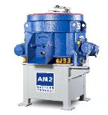
Photo 2: A 3D printed gimble frame before (left) and after the “trowalizing” process.  File name:  Walther-Trowal-AM-Comparision1.jpg | 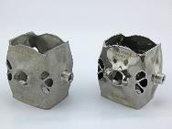
Photo 3a: A 3D printed blisk segment before (left) and after the “trowalizing” process.  File name:  WT-Vorher_Nachher_1_MG_2583.jpg | 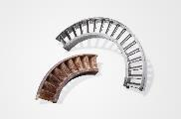
Photo 3b: A 3D printed nozzle before (left), after surface grinding (center) and after polishing.  File name:  WT-Vorher_Nachher_2_MG_2609.jpg | 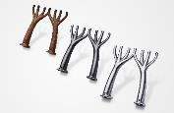
Photo 3c: A 3D printed clip before (left) and after the “trowalizing” process.  File name:  WT-Vorher_Nachher_3_MG_2633.jpg | 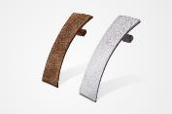
Photo 3d: A 3D printed metal baffle before (left) and after the “trowalizing” process.  File name:  WT-Vorher_Nachher_4_MG_2843.jpg | 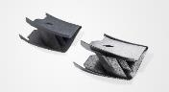
Photo 3e: A 3D printed ear piece for a hearing aid before (left), surface smoothing (center) and after polishing.  File name:  WT-Gleitschleifen_WS (16).jpg | 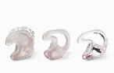
Photo 4: The work pieces are mounted onto a carrier plate, which in turn is electromagnetically clamped to the bottom of the processing bowl.  File name:  WT-AM-0048.jpg | 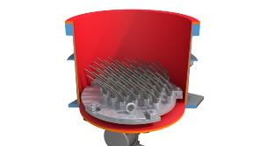
Photo 5: Large work pieces are electromagnetically clamped to the bottom of the processing bowl without the need for a carrier plate.  File name:  WT-AM-0105.jpg | 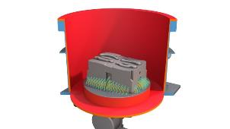
Photo 6: Three vibratory motors induce an overlapping vibratory movement into the processing bowl.  File name:  Unwuchten.jpg | 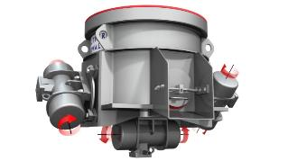
Copyright photos: Walther Trowal
About Walther Trowal
Surface finishing technologies from the inventor of the “Trowalizing” process
Since 1931 Walther Trowal has been developing and producing systems for the refinement of surfaces. Initially focusing exclusively on mass finishing – the term “Trowalizing” derived from the company’s cable address “Trommel Walther” –Walther Trowal has continuously expanded its product portfolio.
Over time the company has developed a broad range of machinery and systems for mass finishing, shot blasting and coating of mass produced small components.
With the invention of new systems like, for example, drag finishing and the development of special finishing methods for 3D printed components the company has proven its innovative capabilities again and again.
Walther Trowal develops and implements complete surface treatment solutions that can be seamlessly integrated into the linked production systems existing at the customers. This includes the entire process technology, perfectly adapted to the specific surface finishing requirements of the work pieces: Equipment and the respective consumables always complement each other in a perfect manner.
Each individual work piece and each manufacturing process must meet special technical requirements. That is why the experienced process engineers in our test lab, in close cooperation with the customers, develop the optimal process technology for the finishing task at hand. The result: Work piece surfaces that meet exactly the required specifications … with short processing times and a high degree of consistent, repeatable results.
Walther Trowal is one of the few manufacturers who develops and produces all machines and mass finishing consumables in-house … including ceramic and plastic grinding and polishing media as well as compounds.
The company’s equipment range also includes all kinds of peripheral equipment for handling the work pieces like lift and tip loaders, conveyor belts and roller conveyors, in addition, special driers for mass finishing applications and, last-but-not-least, systems for cleaning and recycling of the process water.
With its exchange program for wear items like work bowls, which are part of a continuous recycling program, Walther Trowal conserves valuable resources and, thus, makes a significant contribution towards sustainability in the field of industrial production. Quick technical support and the global repair and maintenance service ensure high uptimes for our equipment.
Walther Trowal serves customers in a wide range of different industries all over the world, for example, automotive, aerospace, medical engineering and wind power.

