Facts for the trade press
Mechanical surface finishing
Walther Trowal expands in the United States
Haan, Germany January 21, 2021 Walther Trowal has significantly expanded the facilities of its subsidiary in Grand Rapids, Michigan, that was founded in 2005. It now offers its customers in North- and South-America „just-in-time“ delivery times for the mass finishing media and compounds. In the substantially upgraded „Process Development Lab“ experienced and knowledgeable application engineers assist the customers to optimize the surface finishing solutions for their work pieces.
With the move into a substantially larger facility the Walther Trowal LLC in Grand Rapids, Michigan, has now eliminated the disadvantages of two separate physical locations. With a total area of more than 4,000 m² all the company’s business functions are now under one roof: Sales, service and administration and a threefold larger warehouse area for machines, compounds and media.
Walther Trowal has also expanded the „Process Development Lab“ that is now equipped with a variety of different finishing machines. It allows the American customers to quickly run processing trials with their work pieces in Walther Trowal machinery and, jointly with the company’s application engineers, improve their finishing processes. The lab is not only equipped with mass finishing and shot blast machinery but also coating systems for mass produced small parts.
In the „Tech & Training Centre“ Walther Trowal offers application and training seminars, which are primarily attended by distributors but also by customers from the automobile, machinery building and aerospace industry.
With the new facility Ken Raby, Vice President and General Manager of the Walther Trowal LLC, can now serve his North- and South-American customers even better: „We have significantly expanded our warehouse capacity. This enables us to ship standard media and compounds to our customers from Grand Rapids “just-in-time”. In addition, we are stocking numerous mass finishing machines, which can now be shipped instantaneously”.
Several application and sales engineers at the Grand Rapids office support the already existing nine distributors in the United States and Canada, including the subsidiary company in Queretaro, Mexico. At this location the Walther Trowal LLC founded the Walther Trowal S.A. de C.V. in January 2020. With initially three employees this office has also a test lab and a sizable stock of Trowal products.
Christoph Cruse, general sales manager at Walther Trowal in Haan/Germany, explains why the company is further expanding its presence in the Americas: „We see a continuously growing flow of customer enquiries and purchase orders from North- as well as South-America. Both markets are undergoing a steady growth. With short response times, a large warehouse capacity and intensive on-site technical support, our American customers have perceived us for quite a while as a local player in the field of surface finishing”.
Walther Trowal produces all its mass finishing, shot blasting and coating equipment, as well as compounds and plastic media, at its headquarters in Germany. Ceramic grinding and polishing media are still produced in Great Britain at a facility in Stoke-on-Trent.
470 words including introduction
Contact:  Walther Trowal GmbH & Co. KG  Christoph Cruse  Rheinische Str. 35-37  42781 Haan/Germany  Tel: +49 2129.571-207  www.walther-trowal.de  c.cruse@walther-trowal.de | Contact for the editor:  VIP Kommunikation  Dr.-Ing. Uwe Stein  Dennewartstraße 25-27  52068 Aachen/Germany  Tel: +49.241.89468-55  www.vip-kommunikation.de  stein@vip-kommunikation.de

Photos:
Download of the printable photos: press photos Walther Trowal

Photo 1: All Walther Trowal business functions are now located under one roof on an area of more than 4,000 m².  File name:  WT-IMG-20201103-WA0011.jpg | 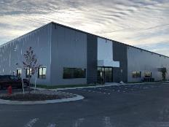
Photo 2: Compared to the old location, the warehouse space for machinery, compounds and media is now three times larger.  File name:  WT_DSC3102_a.jpg | 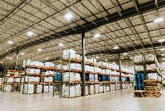
Photo 3: The „Process Development Lab“ allows the customers to quickly run processing trials with their own work pieces in Walther Trowal equipment.  File name:  WT_DSC3278_a.jpg | 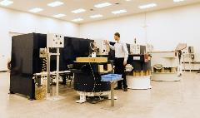
Photo 4: In the „Tech & Training Centre“ Walther Trowal offers a wide range of application and training seminars.  File name:  WT_DSC3450.jpg | 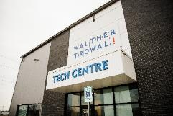
Photo 5: In the „Process Development Lab“ the customers have the opportunity to test the Walther Trowal equipment with their own work pieces.  File name:  WT_IMG_3247.jpg | 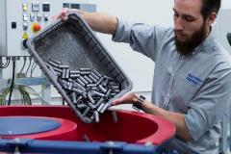
Photo 6: The „Process Development Lab“ is also equipped with machinery for the application of coatings on mass produced small parts.  File name:  WT_IMG_3290.jpg | 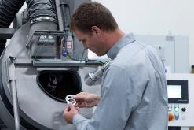
Copyright photos: Walther Trowal
About Walther Trowal
Surface finishing technologies from the inventor of the “Trowalizing” process
Since 1931 Walther Trowal has been developing and producing systems for the refinement of surfaces. Initially focusing exclusively on mass finishing – the term “Trowalizing” originated from the company’s cable address “Trommel Walther” – Walther Trowal has continuously expanded its product portfolio.
Over time the company has developed a broad range of machinery and systems for mass finishing, shot blasting and coating of mass produced small components.
With the invention of new systems like, for example, drag finishing and the development of special finishing methods for 3D printed components, the company has proven its innovative capabilities again and again.
Walther Trowal develops and implements complete surface treatment solutions that can be seamlessly integrated into linked production systems existing at the customers. This includes the entire process technology, perfectly adapted to the specific surface finishing requirements of the work pieces: Equipment and the respective consumables always complement each other in a perfect manner.
Each individual work piece and each manufacturing process must meet special technical requirements. That is why the experienced process engineers in our test lab, in close cooperation with the customers, develop the optimal process technology for the finishing task at hand. The result: Work piece surfaces that meet exactly the required specifications … with short processing times and a high degree of consistent, repeatable results.
Walther Trowal is one of the few manufacturers who develops and produces all machines and mass finishing consumables in-house … including ceramic and plastic grinding and polishing media as well as compounds.
The company’s equipment range also includes all kinds of peripheral equipment for handling the work pieces like lift and tip loaders, conveyor belts and roller conveyors, in addition, special driers for mass finishing applications and, last-but-not-least, systems for cleaning and recycling of the process water.
With its exchange program for wear items like work bowls, which are part of a continuous recycling program, Walther Trowal conserves valuable resources and, thus, makes a significant contribution towards sustainability in the field of industrial production. Quick technical support and the global repair and maintenance service ensure high uptimes for our equipment.
Walther Trowal serves customers in a wide range of different industries all over the world, for example, automotive, aerospace, medical engineering and wind power.

