Press Facts
Screws, bolts, tubes and spokes: Cold forming instead of machining
From the wire coil straight to 300-mm-long full-thread screws of 10-mm-diameter – all in one machine
Cold forming achieves record-breaking throughput.
Alsdorf, Germany, 26 February 2019 A new all-in-one machine from Amba produces full-thread screws of 300 mm length and an outside diameter of 10 mm directly from the coiled wire. While in the screwmaking industry, typically 30 to 40 threads are rolled per minute – this does not include the forming of the screw head – , the new machine achieves a rate of more 100 screws per minute – including the screw head!
The machine designed for the production of full-thread screws used in structural timber design is almost ready to be shipped to a customer in Germany. It is the world’s first machine to produce screws of this length and diameter from the coiled wire to the finished product in just one continuous cycle.
The machine works according to the Amba-developed all-in-one principle, i.e. all process steps from paying off, cutting-to-length and straightening the wire, forming the head to thread rolling are performed by one machine.
Currently, Amba achieves a production rate of more than 100 screws per minute, i.e. three times more than common machines on the market, which only roll the plain threads.
The recipe: Cold forming instead of machining
The new machine is exemplary of a current trend: In the manufacture of long metal components with varying cross-sections along their length, cold forming has been taken over from machining.
Manfred Houben, one of the three Managing Directors of Amba, explains this trend: “Cold forming processes achieve much higher throughput rates than machining operations because the items do not have to be individually fed, clamped, machined and ejected. In this way, discontinuous manufacturing becomes a quasi-continuous process. In certain applications this may result in a productivity improvement of one order of magnitude.“
The all-in-one principle is transferrable to other products, such as pinned joints for bicycle rims. These joints used to be individually turned in a time-consuming process. Now a new machine developed by Amba produces up to 100 joints per minute by cold forming. Amba is currently planning a project intended to replace a three-digit number of automatic turning machines and the associated bar loaders with three Amba machines.
350 words
Background: Amba on a growth course
Amba’s order intake has been growing continuously for several years. As early as in 2018, Amba more than doubled its workshop area and increased its staff from about 50 to more than 70 people. By the take-over of automation specialist Klinken Automation, Amba now combines mechanical design and automation knowhow under one roof.
Amba recently opened a new hall large enough for three machines up to 12 m long and weighing up to 35 t to be assembled at the same time and commissioned under real conditions prior to being shipped to the customers.
Manfred Gottschalk, Managing Director Commercial of Amba, is very happy about the growing interest in Amba technology: “We have been receiving more and more requests from manufacturers who make large quantities of products from wire or tubes as input material. Other projects or requests are in connection with new types of components, particularly for the automotive industry, which for the time being can be produced by conventional techniques nowhere near profitability.”
Amba has also adjusted its corporate structure to the rapid growth. In January 2019, Lars Henning joined the company as third Managing Director. He is responsible for all technology-related areas at Amba: project management, electrical and automation systems, and development. Manfred Houben continues to be in charge of Sales and Production, and Manfred Gottschalk continues to act as Managing Director Commercial.
Background text: 220 words

Figures and captions
High-resolution image files are available for downloading at:
Please click here: AMBA press photos
Fig. 1: The new all-in-one machine produces more than 100 up to 300-mm-long screws per minute in one continuous cycle.  File name:  Amba IMG_9495a.jpg | 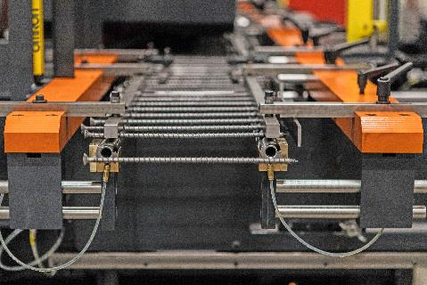
Fig. 2a: The machine forms the screws in one continuous cycle from up to 7.8 mm thick wire directly fed from the coil.  File name:  Amba IMG_9503a.jpg | 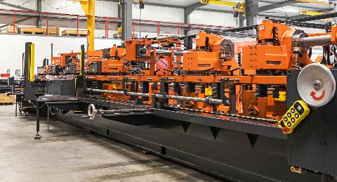
Fig. 2b: The machine forms the screws in one continuous cycle from up to 7.8 mm thick wire directly fed from the coil.  File name:  Amba IMG_9525a.jpg | 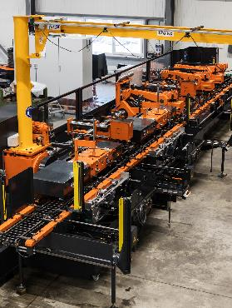
Fig. 3: Manfred Houben (left) and Lars Henning, both Managing Directors at Amba, are inspecting one of the 300-mm-long screws.  File name:  Amba IMG_9511.jpg | 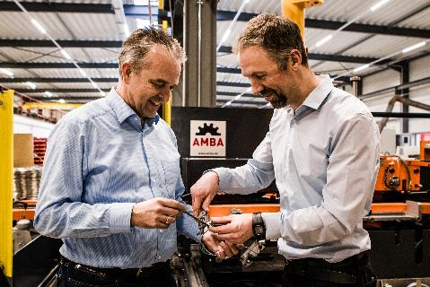
Photos by AMBA Aachener Maschinenbau GmbH
Contact:  AMBA  Aachener Maschinenbau GmbH  Dipl.-Ing. Manfred Houben  Werner-von-Siemens-Straße 17-19  D-52477 Alsdorf/Germany  Fon: +49.2404.551289-0  Fax: +49.2404.551289-10  www.amba.de  houben@amba.de | Press contact:  VIP Kommunikation  Dr.-Ing. Uwe Stein  Dennewartstraße 25-27  D-52068 Aachen/Germany  Fon: +49.241.89468-55  Fax: +49.241.89468-44  www.vip-kommunikation.de  stein@vip-kommunikation.de
About AMBA
Aachener Maschinenbau GmbH – generally referred to as “Amba” – was founded in 1908, at a time when Aachen was worldwide famous for its high-quality needle production. The company has evolved into an internationally renowned builder of machines used to make cold-formed metal components.
Today Amba specializes in machines for the production of long parts with varying cross-sections, for example, bolts between 60 and 2,500 mm long, tubes and spokes. Virtually all world-famous screw and bolt manufacturers are Amba customers, for example, Spax, the Würth Group, Heco and Fischerwerke.
At its headquarters in Alsdorf near Aachen, Amba employs 70 people in its development and design departments, in the workshops and in after-sales service.

