Press information for ALUMINIUM 2022
Optical measurement systems for the aluminium industry
AMEPA: Combined inline roughness and oil film measurement increases productivity of blank forming processes
Unique combination of measuring systems improves proportion of “OK” parts
Würselen, Germany, 15 August 2022 At Aluminium 2022, Amepa is showcasing a tribology measuring system that combines Amepa’s SRM and OFM technology to measure both the roughness and oil film thickness of aluminium and steel strips inline. These two parameters have a decisive influence on the forming process of blanks in press lines, but could not be recorded together until now.
The new, combined system measures both the roughness and oil film thickness of coils inline – for example, at the entry of laser blanking lines. The combined system makes it possible to specifically react to varying properties of incoming strips and optimize the forming process accordingly. In the event that the system detects irregularities, such as poor or missing oiling, the coil can be re-oiled in the respective sections. Likewise, the deep-drawing process can be specifically adjusted to the coil’s surface roughness.
Integrated into coil and blank tracking systems of press shops, the combined system can assign the two parameters "roughness" and "oil film" to the coil sections affected with an accuracy of a meter.
According to Martin Fieweger, Managing Director of Amepa, customers benefit from the combination of the two systems in multiple ways: “For the very first time, data from an inline measurement can be used to adjust the deep-drawing process for each individual blank precisely to the – varying – properties of the coil they are made of. As a result, blanks that had to be downgraded in the past may become “OK” ones thanks to the data provided by our new system. Moreover, based on the data available from the inline coil measurements, operators can gain deeper insights into how the parameters “roughness” and “oil film” influence the forming process and use this knowledge to optimize their processes.”
The two systems are aligned to one another and adjusted by Amepa. They automatically recognize the surface condition and type of lubricant used – dry or fluid – during the measurement.
320 words
Amepa at the Aluminium 2022 trade fair
in Düsseldorf, from 27 to 29 September.
Hall 5, Stand 5H29
Contact:  AMEPA Angewandte Messtechnik und Prozessautomatisierung GmbH  Dipl.-Ing. Jens Harre  Karl-Carstens-Straße 12  D-52146 Würselen/Germany  Phone: +49 2405 40808-11  www.amepa.de  Jens.Harre@amepa.de | Editorial contact:  VIP Kommunikation  Die Content-Agentur für Technik-Themen  Dr.-Ing. Uwe Stein  Dennewartstraße 25-27  D-52068 Aachen/Germany  Phone: +49 241 89468-55  www.vip-kommunikation.de  stein@vip-kommunikation.de

Figures and captions
Link for the download of images in printable quality:
Click here: press photos AMEPA
Fig. 1: The system combines the traversing sensors of Amepa’s surface roughness and oil film measurement systems (SRM and OFM) to measure the strip’ tribological properties.  File name:  Amepa-TriBoSystem.jpg | 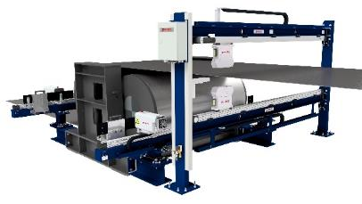
Fig. 2: While traversing across the entire strip width, the SRM sensor can be positioned on measurement tracks previously parameterized by the customer.  File name:  Amepa-SRM-B.jpg | 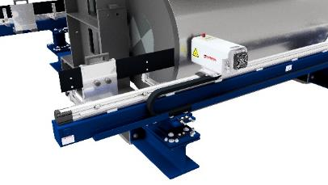
Fig. 3: The OFM system measures the oil film on both sides of the strip.  File name: Amepa_OFM_3D_Presswerk.jpg | 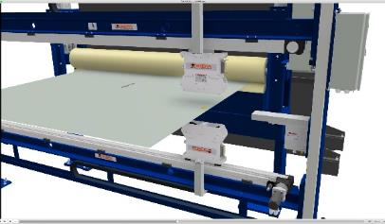
Image rights: Renderings AMEPA GmbH
About AMEPA
AMEPA GmbH has been developing and implementing innovative measuring solutions in close cooperation with the steel, aluminium, and automotive industries since 1984. The core products of the portfolio are electromagnetic and thermographic systems for slag detection, and inline non-contact roughness and oil film measurement. AMEPA systems installed worldwide ensure the highest quality standards along the entire process chain of metals production and processing, from the production of high-purity functional steels to metal forming tribology for rolling and pressing processes in automotive production.
More than 440 installations in 34 countries have made systems from AMEPA a worldwide standard for quality and engineering excellence “Made in Germany.”
With more than 67 employees at the Würselen headquarters, international branches in the USA and China, and a global sales and service network, AMEPA guarantees competent and comprehensive advice and fast service.

