Press information for Aluminium 2024
Optical measurement of oil film on strip
AMEPA: Two-fold better measuring accuracy
New optics concept simplifies validation process and reduces maintenance costs
Würselen, Germany, July 19, 2024 At the Aluminium 2024 trade fair, Amepa will be showing OFM 300, a new inline oil film measuring system, and its OFIS 3.0 hand-held system. Both systems obtain a significantly enhanced measuring accuracy and excel in terms of ease of validation and maintenance.
The Amepa systems are used in cold rolling mills and press lines for automotive production to measure the oil film on aluminium or steel strip. If the systems detect deviations from the specified oiling condition, such as a poor or missing oil layer, specific measures can be taken to re-oil the respective strip sections or check whether the oiling machine is working properly. If used, for example, at the blanking line entry in combination with an Amepa roughness measurement system, the oil film measurement systems make it possible to specifically react to varying properties of the incoming strips and optimize the forming process accordingly.
Amepa has subjected both its OFM system for inline and its OFIS system for manual oil film measurements to a thorough upgrade. The central element of the upgraded system versions is a new optics unit that, in combination with a more refined algorithm and an improved calibration process, provides a two-fold enhanced measurement accuracy. With an oil film thickness of up to 1 g/m², the measurement accuracy is now ± 0.05 g/m². Beyond that thickness, it is ± 5 % of the measured value.
Jens Harre, person of contact for the new product series at Amepa, explains the benefits for the customers: “We have given our systems a fundamentally new design. We have not only improved the measuring accuracy, but also significantly simplified the validation process: All sensors of the OFM 300 are parameterized identically. If one of them needs to be replaced, this can be done right away in the line without any readjustment, markedly reducing the maintenance effort and the effort for the operator during training demonstrations, for example. For our customers, all this results in higher process security at lower costs.”
The new sensor design also facilitates and reduces the time needed for the replacement of consumables such as lamps and fans.
Amepa has supplied more than 480 inline measurement systems and more than 300 OFIS hand-held instruments to customers the world over.
390 words including introduction
Amepa at Aluminium 2024 in
Düsseldorf, Germany,
8 - 10 October 2024
Hall 5, Stand 5H14
Contact:  AMEPA Angewandte Messtechnik und Prozessautomatisierung GmbH  Dipl.-Ing. Jens Harre  Karl-Carstens-Straße 12  52146 Würselen/Germany  Phone: +49 2405 40808-11  www.amepa.de  Jens.Harre@amepa.de | Contact for the media:  VIP Kommunikation  Die Content-Agentur für Technik-Themen  Dr.-Ing. Uwe Stein  Dennewartstraße 25-27  52068 Aachen/Germany  Phone: +49.241.89468-55  www.vip-kommunikation.de  stein@vip-kommunikation.de

Figures and captions
Link for the download of images in printable quality:
click here: press photos AMEPA
Fig. 1: The new layout of the OFM 300 inline sensor for oil film measurements achieves a higher measuring accuracy at reduced maintenance costs.  File name:  Amepa-mh521360_AMEPA0063_bearb_Licht-2.jpg | 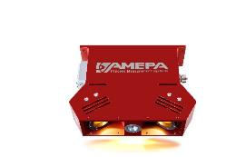
Fig. 2: The OFM 300 inline sensor is moved across the entire strip width.  File name:  Amepa_DSC_0330.jpg | 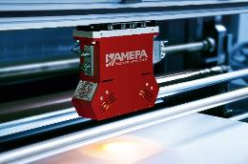
Fig. 3: Also the OFIS 3.0 hand-held instrument features a measurement accuracy improved by a factor of 2.  File name:  Amepa-mh521427_AMEPA0132_bearb_mit-Surface-Screen-2.jpg | 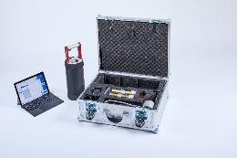
Fig. 4: Validation with the new validation set for the OFIS 3.0 does not require any additional parameterization.  File name: Amepa-mh521434_AMEPA0141_bearb.jpg | 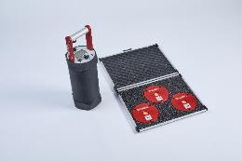
Image rights: AMEPA GmbH © 2024
About AMEPA
Since 1984, AMEPA GmbH has specialized in the development and implementation of innovative measuring solutions in close cooperation with the steel, aluminium and automotive industries. The core products of the company’s portfolio include electromagnetic and thermographic systems for slag detection, and inline non-contact roughness and oil film measurement. Worldwide, AMEPA systems ensure the highest quality standards along the entire process chain of metals production and processing, from the production of high-purity functional steels to metal forming tribology for rolling and pressing processes in automotive production.
With more than 480 installations in 34 countries, systems from AMEPA have meanwhile become a worldwide standard for quality and engineering excellence “Made in Germany.”
AMEPA guarantees competent and comprehensive advice and fast service with its more than 70 employees at the Würselen headquarters, international branches in the USA and China, and a global sales and service network.

