Press facts
Customized blends for producers, processors and recyclers of plastics
Blend+ on expansion course
Dr. Ralf Moritz takes responsibility as shareholder
Düren, Germany, 5 May 2025 Blend+ GmbH is expanding its facilities in Düren and investing in new production plants to be able to comply with its customers’ growing demand for innovative plastic additive blends. This coincides with a strengthening of the company’s management team: Dr. Ralf Moritz, who joined the company in 2021 and has been Managing Director since 2023, is now also a shareholder of the company. Building on strong technological expertise and entrepreneurial farsightedness, Blend+ has thus set the course for further growth.
Blend+ was founded in 2015. The company’s orders, particularly those for customized products and services, have been on a continuous rise for many years. Blend+ produces blends from a wide range of additives, including thermostabilizers, acid scavengers, clarifiers, anti-slipping and anti-fogging agents, and flame retardants. On account of its sustainable success, the company decided to expand the production capacity at its headquarters in Düren. With this investment, Blend+ is responding to the increasing requirements of the market and forming the basis for further growth.
New equipment for the capacity expansion is already being installed and will be commissioned shortly. It includes technology for both the production of standard compacted additives in granular form and the development of new product forms at industrial scale.
Enlarged circle of shareholders
Dr. Ralf Moritz, the second Managing Director alongside Hans Houben, now also owns shares in the company, taking over additional responsibility for the long-term strategy of the company.
Dr. Moritz earned a doctoral degree at the Max Planck Institute for Polymer Research in Mainz, Germany, and holds an MBA in Digital Transformation Management from Frankfurt-based Goethe Business School. He gained practical experience at the business consultancy firm KPMG and, subsequently, as sales manager at the Japanese chemical group Adeka.
Hans Houben, one of the two founders of Blend+, will continue to be Managing Director and shareholder of the company and actively accompany Blend+ as project manager in future investments: “Contrary to the current trend, we have been growing continuously. With Ralf Moritz, we have a highly acknowledged expert on board who acts with a strong customer focus and has a clear view of the long-term development of our company.” Joachim Bayer – founder, shareholder, authorized signatory, and sales director – completes the management team of Blend+. With his technical expertise in plastics stabilization, he has played a key role in the success of Blend+. Joachim Bayer gained experience in various technical and commercial management positions at international corporations in the plastics industry.
2,700 characters including introduction and blanks

Contact:  Blend+ GmbH  Kreuzauer Straße 46  52355 Düren/Germany  Phone: +49 2421 555950  www.blendplus.de  sales@blendplus.de | Contact for the media:  VIP Kommunikation  Die Content-Agentur für die komplexen Technik-Themen  Dr.-Ing. Uwe Stein  Dennewartstraße 25-27  52068 Aachen/Germany  Phone: +49 241 93858814  www.vip-kommunikation.de  stein@vip-kommunikation.de

Figures and captions
click here: press photos Blend+

Fig. 1: Dr. Ralf Moritz  File name:  blend+_2025-04_RalfMoritz_013.jpg | 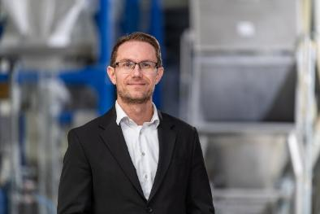
Fig. 2: The Blend+ management team: Hans Houben, Ralf Moritz (both Managing Directors and shareholders), Joachim Bayer (founder, shareholder and Sales Director) and Jens Hannott (Director Operations) (from left to right)  File name:  blend+_2025-04_082.jpg | 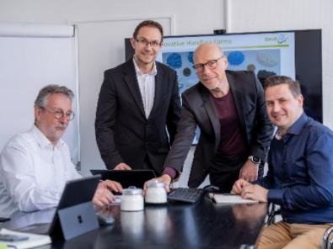
Fig. 3: The unique design of its production lines, which are one-of-a-kind in the plastics processing sector, enables Blend+ to produce blends of most complex formulations, and specialty blends in virtually any batch size.  File name:  Blend-plus-Muster.jpg | 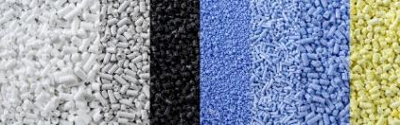

Image rights: Blend+ GmbH

About Blend+
Hans Houben and Joachim Bayer founded Blend+ in 2015. Till today, they have consistently followed their business idea of supplying - as an independent producer - customized specialty blends at affordable prices, employing latest technology and highly efficient production processes.
Another key element of the company’s business strategy has been the focus on the development of customized blends in order to stand out clearly from the mass of companies offering contract mixing services. This strategy has proved highly successful to the present day.
Thanks to Blend+’s ultra-modern machines and equipment, and the high-precision process control systems, the company is one of very few producers able to supply blends of repeatable quality containing additives that are known to be very difficult to handle.

