Press facts about TUBE 2022
Production of large-diameter pipes: high precision in complying with form tolerances
Premiere at TUBE 2022
Dango & Dienenthal: Pipe Sizing Technology for the perfect inner pipe contour
Inline laser measurement replaces “trial and error”
Siegen, Germany, 7 March 2022 At TUBE, Dango & Dienenthal (D&D) will present laser-assisted calibration of large-diameter pipes for the first time. The machines of the PST series achieve unprecedented levels of precision. At the same time, they drastically reduce the time required for straightening and allow complete documentation of the inner contour.
The basic new feature of Pipe Sizing Technology (PST) is that a 360° circular laser measures the inner contour of the pipe during the straightening process, with the results being immediately incorporated into the process. The machines of the PST series are generally used for straightening. The PST-PE-EX version is also capable of expanding the pipe ends, while the PST-FB version (full body sizing) straightens the pipes over their entire length.
The laser mounted in the measuring head projects a line onto the inner wall of the pipe. A camera, also located in the measuring head, captures the circular line with up to 3,200 measuring points over the entire circumference of the pipe. In this way, the complete image of the inner contour of the pipe is created in real time. This data is the basis for controlling the straightening tools.
For sizing, the PST-PE machines are equipped with six expanding jaws, which are precisely controlled according to the results of the laser measurement. The result: the pipe is not expanded, but instead retains its original inner circumference.
Since the Pipe Sizer combines measuring and forming, the systems drastically reduce the time required for handling the pipes. This means that considerably more pipes can be straightened per shift than with conventional systems. For example, laser contour measurement makes it possible for the first time to measure each individual pipe and document its geometry – such as inner circumference and ovality – in a short amount of time.
The first PST-PE-EX machine, currently being manufactured by D&D for a German manufacturer of large-diameter pipes, will straighten and expand the ends of pipes with diameters between 270 and 1,016 mm with wall thicknesses of up to 60 mm. Here, too, the circular laser provides the inner contour of the pipe end, which is used to control the pressure cylinder.
Denis Albayrak, Senior Sales Engineer at D&D, places great importance on precise laser measurement: “The demands on the quality of pipes – especially when it comes to optimal roundness – have grown steadily in recent years, presenting pipe manufacturers with enormous challenges. With Pipe Sizing Technology, we replace “trial and error” with exact measured values. After sizing, the finished pipes have a perfect circular shape, while the specified nominal diameter remains unchanged.”
430 words including header
Dango & Dienenthal at TUBE 2022
Düsseldorf, June 20–24, 2022:
Hall 5, Booth 5F08

Background: The technology in detail
The measuring system mounted on the face of the pipe sizer works according to the principle of laser triangulation: a circular laser projects a line over the entire inner circumference of the pipe. A camera captures the line with 3,200 points distributed around the pipe circumference, which corresponds to an angular resolution of about 0.17 degrees. For pipe diameters up to 1,600 mm (64 in), the contour measurement resolution is 0.1 mm; for systems for nominal diameters up to 1,000 mm, it is 0.05 mm.
The software uses the results to calculate the default values for the expanding jaws and transmits them to the process control system. When sizing with the PST-PE and PST-FB versions, the six expansion segments distributed around the circumference of the pipe are individually controlled by hydraulic cylinders depending on the geometry of the pipe.
Once the initial sizing process is complete, the pipe is measured again. With this contour data, the software determines the springback value of the pipe material and calculates it into the second sizing process. This way, the individual material properties of each pipe are utilized for pinpoint sizing.
Background: 190 words

Contact:  Dango & Dienenthal Maschinenbau GmbH  Hagener Str. 103  57072 Siegen/Germany  www.dango-dienenthal.de  Denis Albayrak  Senior Sales Engineer  Tel.: +49 271 401-4126  E-mail: denis.albayrak@dango-dienenthal.de | Editorial contact:  VIP Kommunikation  Dennewartstraße 25-27  52068 Aachen/Germany  www.vip-kommunikation.de  Dr.-Ing. Uwe Stein  Tel: +49 241 89468-55  E-mail: stein@vip-kommunikation.de

Illustrations:
Fig. 1: The first machine currently being manufactured by D&D straightens and expands the pipe ends.  File name:  DD_PST_PE_EX_1.jpg | 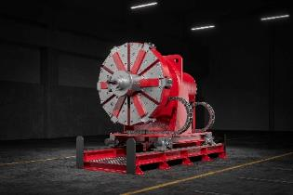
Fig. 2: When sizing the pipe ends, the circular laser first measures the inner contour, then the expanding jaws are applied.  File name:  DD_PST-PE-360_1.jpg | 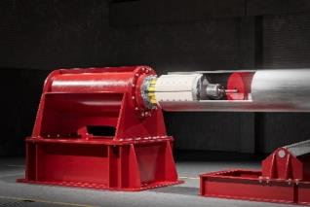
Fig. 3: During the full body sizing process, the pipe is processed along its entire length.  File name:  DD_PST-FB.jpg | 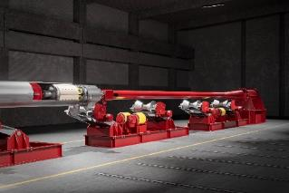

Image rights: Dango & Dienenthal Maschinenbau GmbH
About the Dango & Dienenthal Group
DANGO & DIENENTHAL is a company with a long tradition: it was founded in 1865 as a non-ferrous metal foundry by August Dango and Louis Dienenthal. Since then, the company has developed into the world-renowned premium manufacturer of special machinery and plants for the production, forming and processing of semi-finished products made of steel and non-ferrous metals. The company's main areas of expertise are:
- Melting and forging
- Rolling and bending
- Heat treatment
The scope of delivery includes:
- Tapping and measuring equipment for blast furnaces (e.g. taphole openers, clay guns, cover manipulators and probes)
- Machines for open-die and closed-die forging as well as ring rolling plants (e.g. forging and transport manipulators, heavy-load robots and handling machines)
- Automated transport equipment for heat treatment (e.g. transport manipulators, heavy-load robots and handling machines)
- Tending machines for melting furnaces (charging, stoking and distribution machines)
- Deslagging equipment
- Machines for the pipe industry (e.g. pipe sizing tools, expanders and bending machines)
- Equipment for liquid filtration (filter systems and separators)
At the heart of our work is thinking in terms of processes, so that customers can produce forgings, rings, pipes and plates that precisely meet their clients' specifications. This also includes the customer-specific integration of the equipment into the increasingly complex digital data world of the plants.
The machines operate with maximum precision, even under extreme operating conditions. Their MORE in robustness ensures high availability in production day in, day out and thus makes a decisive contribution to the customers' efficient production processes.

