Press facts
Manipulators for heat treatment
Dango & Dienenthal:
Successful “remote” commissioning of two heavy-load robots
Programmers control new machine from nearly 7,000 km away
Siegen, Germany, November 2, 2021 At the Siegen plant, Dango & Dienenthal (D&D) performed its first online commissioning of manipulators and heavy-duty robots for a forge. Not only does this save the expense of travel, but it also gives the customer confidence that the machines will meet its requirements even before they are shipped.
Previously, it was customary for future users to visit the supplier’s plant for a preliminary acceptance inspection of the finished machines. This way, they could satisfy themselves that the machines met the contractually agreed specifications. In exceptional circumstances, preliminary factory acceptance and factory commissioning can be a viable alternative.
As D&D supplies more and more fully automated heavy-load robots and manipulators, machine programming plays a critical role in commissioning. To ensure that the preliminary acceptance processes take place under realistic conditions, D&D replicates the situation on the user’s premises directly at the Siegen plant.
This way, the company not only demonstrates the functionality of the individual components of the machines, but also their integration into the customer’s process.
Recently, D&D recreated to scale the future environment of two SLR heavy-load robots with a transfer table, two furnaces and a quenching bath in the Siegen plant. Local specialists of the project partner, who was responsible for the automatic control system, tested all functions remotely from their laptops and programmed different sequences and missions. In the process, they watched the movements of the SLR via a webcam. A D&D employee could have intervened at any time if necessary.
Other specialists were also involved in the acceptance process, such as electricians and hydraulic engineers. It was important for them to check the mechanical design as well as the electrical and hydraulic installation of the new machine in detail. For this reason, one of D&D’s employees wore AR glasses that transmitted their images along with imported data. If the future users wanted to see individual parts of the installation in detail, they could direct the employees in Siegen to the appropriate places.
During the acceptance process, D&D proved that all contractual conditions had been met, such as the cycle times for transferring the workpieces from the furnaces to the quenching bath. In addition, the programmers were assured long before on-site commissioning that the control system also met their expectations.
Ilias Gintikas, the responsible project manager at D&D, sums up the situation: “In this case, the effort required for factory acceptance was indeed higher than it would have been if acceptance had taken place in the presence of the future user at our plant. But we are pleased that we were able to provide our customer with a solution in an exceptional situation.”
440 words including header
Contact:  Dango & Dienenthal Maschinenbau GmbH  Normann Blasig  Hagener Straße 103  57072 Siegen/Germany  Tel: +49 271 401-4150  www.dango-dienenthal.de  normann.blasig@dango-dienenthal.de | Editorial contact:  VIP Kommunikation  Die Content-Agentur für die komplexen Technik-Themen  Dr.-Ing. Uwe Stein  Dennewartstraße 25-27  52068 Aachen/Germany  Tel: +49 241 89468-55  www.vip-kommunikation.de  stein@vip-kommunikation.de

  - Images
Download of image files: press photos D&D
Fig. 1: D&D has simulated the future environment of heavy-load robots at the Siegen plant.  File name:  D&D_IMG_20210128_175344.jpg | 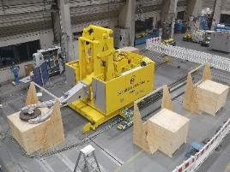
Fig. 2: The programmer at the customer’s plant tracked the robot’s movements via webcam.  File name:  D&D_IMG_20210128_154952.jpg | 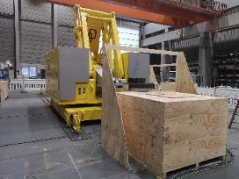
Fig. 3: The SLR precisely placed the workpieces in the replicated furnace – controlled from several thousand kilometers away.  File name:  D&D_IMG_20210128_154855.jpg | 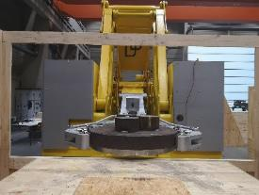
Fig. 4: The future users were able to direct the employee in Siegen online to any location they wanted to see in detail.  File name:  D&D-Hololens-57.jpg | 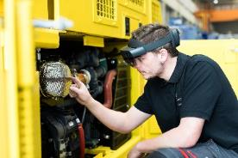
Image rights: Plant photos Dango & Dienenthal Maschinenbau GmbH

About Dango & Dienenthal Maschinenbau GmbH
Founded in 1865, Dango & Dienenthal Maschinenbau GmbH designs and manufactures special machinery for the metallurgical industry.
The product range includes machines for open-die and closed-die forging as well as for ring-rolling plants – forging and transport manipulators, heavy-load robots and handling machines, for example. The company also designs and supplies deslagging equipment for steel mills, transport equipment for reduction furnaces and heat treatment as well as equipment for liquid filtration.
The range of services also includes the design and planning of complete machines and plants, their manufacture and assembly, commissioning and after-sales service.
The company also offers retrofitting and servicing of hydraulic and hydroforming presses as well as press dismantling and installation at new sites.

