Press Information
Towards the Smart Coil – Digitalize your press blanking line
Premiere at Euroblech:
Track & trace system with integrated functions for optical inline quality control
New camera unlocks potential of image processing for part tracking
Regensburg, Germany, 9 August 2022 At the Euroblech trade fair, evopro systems engineering AG is showing its evoTrQ track & trace system for the first time in combination with its new, inhouse-developed evoVIU smart cameras. The new camera technology adds several new functions to evopro’s continuous blank tracking system for press blanking lines. From now on, functions like inline measurement of blank dimensions, embossed part ID reading and crack detection during deep-drawing are available to the line operator.
Several European automotive producers already use the evoTrQ track & trace system for continuous tracking of blanks along all process stages in the press shop.
With “smart coils” becoming increasingly popular, more and more strips come with barcodes printed on their surfaces. Installed at the uncoiler, the new evoVIU cameras read these barcodes as the coils are being fed into a laser blanking line. This makes it possible to assign material data, such a thickness, roughness and tensile strength, with an accuracy of one meter to the entire coil length.
In addition to this, the new smart cameras developed by evopro for optical inline control can also be used in downstream production stages for a variety of functions, such as reading embossed part IDs, inspecting the blanks for cracks, checking the blanks’ dimensions and verifying that cut-outs are in the correct position. evoTrQ relates the data captured by an evoVIU camera to the individual blanks, processes the data for visualization and stores them for analysis purposes.
Karl-Heinz Fröhning, Manager Sales at evopro, sees great opportunities to move digitalization in blanking lines forward: “With our new cameras and the advanced image processing capabilities and sophistication of algorithms they provide, we can unlock additional digitalization potential for the processes in a blanking line. We are able to capture virtually all parameters visible to the cameras in addition to the measured strength and roughness values. Line operators can instantly react in the event that a blank’s dimensions or the positions of cut-outs are not correct, or cracks are detected. Integrating the image data into evoTrQ also makes it possible for them to see at a glance whether other blanks are affected. If necessary, they can remove individual sections or all blanks cut from a coil to prevent them from being further processed. This saves time and money.”
The new camera is designed for wireless integration into higher-level systems via WiFi or 5G. As a battery-powered system, the camera can also be installed in places without a power supply, as, for example, at crossbar feeders.
400 words
evopro at Euroblech 2022
Hanover, Germany, 25 to 28 October 2022
Hall 11, Stand B08
Background information on evoTrQ
In press blanking lines, the cloud-based part tracking system evoTrQ ensures continuous tracking of each individual blank from the uncoiler via the forming stages up to where the blank is discharged from the line. The system captures, stores and visualizes all relevant production and quality control data. Thus, all data related to each one of the blanks are always readily available. Throughout the production process, the operators know the exact status of each individual blank, enabling them to immediately intervene, if necessary.
With evoTrQ, you maximize the production rate of your blanking line and the quality of your products. High-performance analysis tools help line operators to optimize their production processes and ensure that only products that comply exactly with their customer’s specifications are shipped.
Background information: 130 words
Contact:  evopro systems engineering AG  Karl-Heinz Fröhning  Im Gewerbepark A 52  93059 Regensburg/Germany  Phone: +49 941 899645–19  www.evopro-ag.de  Karl-Heinz.Froehning@evopro-ag.de | Editorial contact:  VIP Kommunikation  Die Content-Agentur für die komplexen Technik-Themen  Dr.-Ing. Uwe Stein  Dennewartstraße 25-27  52068 Aachen/Germany  Phone: +49 241 89468-55  www.vip-kommunikation.de  stein@vip-kommunikation.de

Figures and captions:
Link for downloading image files in print quality: presse photos evopro
Fig. 1: evopro has designed its smart evoVIU cameras specifically for use in the automotive industry.  File name:  evopro_reading laser code.jpg | 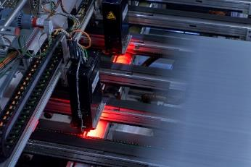
Fig. 2: An evoVIU camera checking a deep-drawn component for cracks.  File name:  evopro-Risserkennung-3.png | 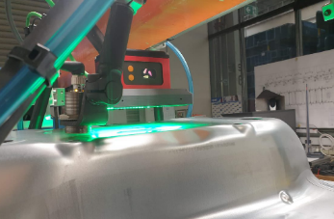
Fig. 3: The evoVIU cameras integrate seamlessly with the other elements of the evoTrQ system.  File name:  evopro-extensible-and-flexible-E.png | 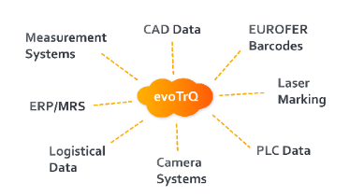
Image rights: evopro systems engineering AG
About evopro
Founded in 2009, evopro systems engineering AG specializes in cross-technology solutions for industrial applications. The company focuses on the development and construction of production, control and inspection systems – including dedicated electronic and software systems – for customers in industries such as automotive, semi-conductor and mechanical engineering. The portfolio ranges from automation technology, the associated software and hardware, to image processing systems and robotics through to commissioning services, both on-site and virtually.
Systems from evopro are generally one-stop solutions, jointly achieved by all departments of the company. Customers benefit from this in the form of economic solutions with harmonized interfaces.
85 employees work at the company’s headquarters in the German city of Regensburg. With its global network of branches and representations, evopro is always close to customers worldwide.

