Press Facts for JEC World 2022
Technical textiles made from aluminium-coated high-performance fibres
FibreCoat GmbH:
Significant quality and cost advantages for electromagnetic shielding
New production process reduces costs to a fraction
Aachen, Germany, March 8, 2022 At JEC World 2022, May 3-5 in Paris, FibreCoat from Aachen, Germany, will introduce its new AluCoat product line for the first time as part of the Startup Booster competition. The company uses the aluminium-coated basalt fibres to produce short fibres, yarns and fabrics for electromagnetic shielding in electric vehicles, aerospace and buildings, among other applications.
FibreCoat founders Robert Brüll, Alexander Lüking and Richard Haas have succeeded in sheathing individual basalt fibres with aluminium in an economical process, reducing production costs to a fraction of those of conventional methods. “Our innovative high-performance fibres not only improve existing products,” as Brüll explains, “but also enable completely new EM shielding applications in electric vehicles or aerospace applications with lightweight, flexible fabrics. AluCoat also opens up completely new possibilities for smart textiles or shielding in buildings.”
The AluCoat product line includes chopped fibres and yarns that consist of up to 100 individual fibres, as well as woven or nonwoven fabrics. They are thermally and electrically conductive and temperature resistant up to 600 °C (1,100 °F). The material properties can be precisely adjusted via parameters such as the thickness of the coating or the diameter of the core fibres and adapted to customer-specific requirements. At the same time, FibreCoat's coating technology offers significant quality and cost advantages in electromagnetic shielding compared to existing technologies such as pure aluminium fibres, aluminium foils or sheets.
“And the winner is: FibreCoat!” was stated at the JEC Forum DACH (www.jec-dach.events) in Frankfurt at the end of November 2021. The start-up from Aachen won the “JEC Composites Startup Booster” competition there. Citing that FibreCoat “makes it possible to use cost-effective two-component materials in lightweight construction, electromagnetic shielding and industrial filtration.” This also qualified FibreCoat for the Startup Booster competition at JEC World 2022 in Paris.

approx. 300 words

FibreCoat at JEC World 2022:
Paris Exhibition Centre,
May 3-5, 2022, "Startup Booster" Stand.

The JEC World 2022 Startup Booster competition will take place on the Agora stage in Hall 5. FibreCoat is competing in the “Products & Materials” category. The finalists will present their pitches on Tuesday, May 3, from 10 am to 11:25 am. The awards ceremony will follow at 2:45 p.m. on Wednesday, May 4.

Figures and captions
Fig. 1: Bi-component multifilament yarns with basalt core and aluminium sheathing consist of up to 100 individual fibres.  File name: 3a-roll-komplett.jpg  Photo copyright: FibreCoat GmbH | 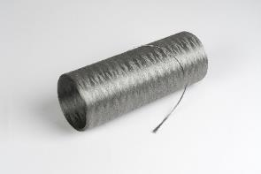
Fig. 2: The metal-coated AluCoat basalt fibres for EM shielding are available as chopped fibre, yarn, fabric or fleece.  File name: 5-kombination-b.jpg  Photo copyright: FibreCoat GmbH | 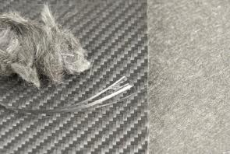
Fig. 3: The FibreCoat founders: Dr. Alexander Lüking, Richard Haas and Dr. Robert Brüll (from left).  File name: 20200519_173434.jpg  Photo copyright: FibreCoat GmbH | 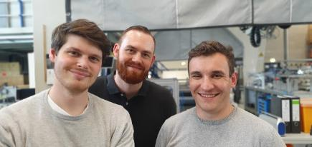
Fig. 4: Visitors at JEC World 2022 will find FibreCoat at the "Startup Booster" stand and receive AluCoat product samples on request.  File name: JEC World_FibreCoat_Startup Booster  Photo copyright: JEC GROUP | 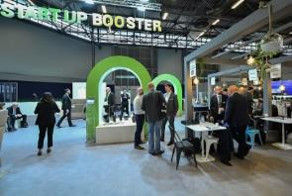

Contact:  FibreCoat GmbH  Joris Kemperman  Dennewartstraße 25-27  52068 Aachen, Germany  Tel: +49 241 93688538  www.fibrecoat.de  joris.kemperman@fibrecoat.de | Editorial contact:  VIP Kommunikation  Martin Grolms  Dennewartstraße 25-27  52068 Aachen, Germany  Tel: +49.241.89468-25  www.vip-kommunikation.de  grolms@vip-kommunikation.de

About FibreCoat GmbH
FibreCoat GmbH is a start-up company based in Aachen, Germany, offering a revolutionary coating technology for coated fibres in composite and shielding applications as a basic building block for tomorrow's mobility and construction industries. To make high-performance materials affordable for high-volume production, FibreCoat focuses on continuous innovation and strong partnerships. Learn more at https://www.fibrecoat.de

