Press Facts
Technical textiles made from aluminium-coated high-performance fibres
FibreCoat GmbH:
FibreCoat wins with aluminium-coated fibre
Versatile and affordable: AluCoat impresses expert jury and specialist audience at Startup Booster Competition at JEC World 2022 in Paris
Aachen, Germany, 20 May 2022 FibreCoat has succeeded in coating individual basalt fibres with aluminium. The start-up has already been awarded many prizes for this: Just recently it was Plug and Play Japan Expo Winner, last year it received the IQ Innovation Award Mitteldeutschland, before that the Théophile Legrand International Prize, the Shenzhen Innovation Award and it won the hello tomorrow Global Challenge, and so on. FibreCoat is one of the top start-ups in Germany. But the Startup Booster competition at JEC World 2022 in Paris is something very special.
“The JEC Composites Startup Booster Competition has become a reference in the composites industry,” explains Robert Brüll. Each year, 20 qualified finalists from all over the world take part and present their project to the international audience of specialists. Since 2020, the founders Robert Brüll, Alexander Lüking and Richard Haas have been developing and marketing this special high-performance fibre. Compared to the aluminium fibres commonly used to date, the costs of production are reduced to a tenth.
With this, the Germany-based company prevailed over the strong competition in the Startup Booster competition. They convinced the jury of experts in an exciting pitching session and were finally awarded the coveted prize on 4 May because they “make high-performance materials affordable”, as the jury said.
“This competition is a great opportunity to make contacts, see what others are doing and explain our aluminium basalt fibre AluCoat in detail,” states Alexander Lüking happily. AluCoat is FibreCoat's first market-ready product. Unlike conductive polymer yarns currently in use, AluCoat is thermally and electrically conductive and temperature resistant up to 600 °C (1100 °F).
The AluCoat product line includes chopped fibres and yarns consisting of up to 100 individual fibres, as well as woven or non-woven fabric. The material properties can be precisely adjusted via parameters such as the thickness of the coating or the diameter of the core fibres and adapted to customer-specific requirements.
“Our innovative high-performance fibres not only improve existing products,” says Brüll, “they offer opportunities for completely new applications with lightweight, flexible fabrics. AluCoat opens up new possibilities for smart textiles or electromagnetic shielding in vehicles or buildings.”
Visitors can also get to know the AluCoat product line at the international trade fair for technical textiles and nonwovens Techtextil from 21 to 24 June 2022 in Frankfurt am Main. Please, make an appointment with FibreCoat at:
info@fibrecoat.de
approx. 400 words

Figures and captions
Fig. 1: The JEC Composites Startup Booster Competition is a global reference in the composites industry. FibreCoat prevailed in the final against 20 innovative and successful start-ups from all over the world.  File name: LDP_8509.jpg  Photo copyright: FOUCHA-MUYARD | 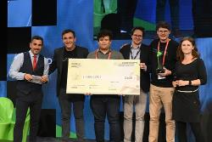
Fig. 2: Visibility in front of an international expert audience: FibreCoat convinces with the versatile and affordable aluminium basalt fibre AluCoat and wins the Startup Booster Competition at JEC World 2022 in Paris.  File name: LDP_8554.jpg  Photo copyright: FOUCHA-MUYARD | 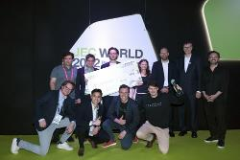
Fig. 3: The metal-coated AluCoat basalt fibres offer opportunities for completely new applications. They are available as chopped fibre, yarn, as woven or non-woven material.  File name: 5-kombination-b.jpg  Photo copyright: FibreCoat GmbH | 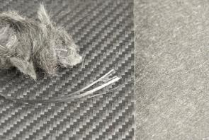
Fig. 4: FibreCoat wins the coveted JEC World Startup Booster Competition 2022.  File name: LOGO-SB-WINNER-2022.png  Photo copyright: JEC GROUP | 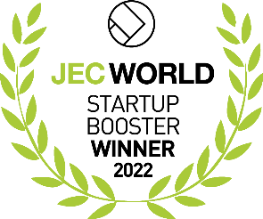

Contact:  FibreCoat GmbH  Joris Kemperman  Dennewartstraße 25-27  52068 Aachen, Germany  Tel: +49 241 93688538  www.fibrecoat.de  joris.kemperman@fibrecoat.de | Editorial contact:  VIP Kommunikation  Martin Grolms  Dennewartstraße 25-27  52068 Aachen, Germany  Tel: +49.241.89468-25  www.vip-kommunikation.de  grolms@vip-kommunikation.de

About FibreCoat GmbH
FibreCoat GmbH is a start-up company based in Aachen, Germany, offering a revolutionary coating technology for coated fibres in composite and shielding applications as a basic building block for tomorrow's mobility and construction industries. To make high-performance materials affordable for high-volume production, FibreCoat focuses on continuous innovation and strong partnerships. Learn more at https://www.fibrecoat.de

