Press facts
Digital 3D fingerprint capture with microscopic resolution
IDloop:
More speed and security for fingerprint capture
European Union selects Thuringia-based biometrics startup IDloop for €10 million funding.
Jena, Germany, February 16, 2023 The startup IDloop has developed the world's first 3D scanner that captures fingerprints without contact and with microscopic resolution. It drastically speeds up matching with existing databases and is secure and hygienic. To develop the system to market readiness, the European Commission has selected the project for €10 million in funding under the EIC Accelerator.
More than three billion people are currently registered in government fingerprint databases. All of this data was recorded contact-based - by touching scanner surfaces - and to this day can only be matched in this way. They are used, for example, in access and border controls and in applying for and matching biometric identification documents, as well as in criminalistics and voter registration.
Contact-based fingerprint capture and verification is time-consuming, inconvenient, and unhygienic. Many contactless scanners are not secure and the data formats are not compatible with existing databases.
In contrast, IDloop's optical 3D imaging technology captures the fingerprint characteristics that are unique to each person, contactlessly, with microscopic resolution and in a fraction of a second. The users hold one hand over the optics for a short time, while the scanner captures the 3D image. The image acquisition of both hands, including post-processing, takes less than ten seconds. This significantly speeds up handling, for example in international travel.
The patent-pending scanner operates at a resolution of ten micrometers, which is about one-fifth the thickness of a human hair. From this 3D data, the system calculates 2D grayscale images in real time, i.e. "classic" fingerprint images". Thus, for the first time, fingerprints taken without contact are compatible with existing fingerprint databases. In addition, the unrivaled level of detail of the novel 3D capture technology increases the accuracy of database matching and counterfeit detection.
Jörg Reinhold, CEO at IDloop, brings long experience in image processing: "The micrometer-accurate detection of moving objects, for example the hand in our scanner, is one of the challenging tasks in biometric image capture. With high-performance graphics processors and artificial intelligence-based software, we have managed to fit this complex issue into an easy-to-use device measuring just 15 x 15 x 15 cm."
2,600 characters including preamble and spaces
Ten million euros from the European Union
The European Union is supporting the further development of the system to market readiness as part of its "EIC Accelerator" program with ten million euros, consisting of grants and investments through the EIC Fund. IDloop is the first company from Central Germany - and thus also the first from Thuringia, - to qualify for this European program.
Marion Walsmann (CDU), Member of the European Parliament from Thuringia, is excited for IDloop: "With the new system, IDloop is setting a new standard in biometrics in the global market. The project is an impressive example of how Thuringian companies and research institutions work hand in hand with Europe. This is how technology from Thuringia reaches the whole world."
700 characters including spaces

Contact:  IDloop GmbH  Philipp Riehl  Business Development  Moritz-von-Rohr-Straße 1a  07745 Jena  www.id-loop.de  Phone: +49 17697694983  E-Mail: p.riehl@id-loop.de | Editorial Contact:  VIP Communication  The content agency for technology topics  Dr.-Ing. Uwe Stein  Dennewartstrasse 25-27 52068 Aachen  www.vip-kommunikation.de  Tel: +49 241 89468-55  E-Mail: stein@vip-kommunikation.de

Illustrations:
Download the printable images: IDloop
Fig. 1: Structured light illuminates the hand, from which the system generates a 3D point cloud that it converts into a 2D image.  Filename:  IDloop_hand_from_down2.png | 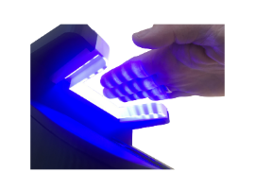

Fig.2: The scanning process is completed in less than a tenth of a second.

Filename:
IDloop_7.png
Fig. 3: The scanner requires a footprint of just 15 x 15 cm.  Filename:  IDloop image1.jpg | 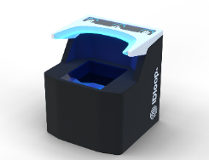
Fig. 4: Structured light illuminates the hand.  Filename:  IDloop image2.jpg | 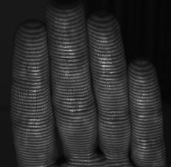
Fig. 5: The scanner generates a 3D point cloud.  Filename:  IDloop image3.png | 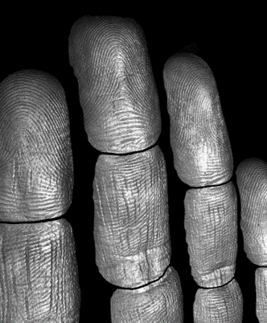
Fig. 6: From the point cloud, the software calculates the 2D image, which is compatible with existing fingerprint databases.  Filename:  IDloop image4.png | 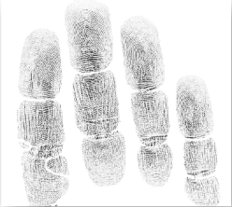
Fig. 7: Structured light illuminates the hand (left), from which the system generates a 3D point cloud (center) that it converts into a 2D image (right).  Filename:  IDloop image5.png | 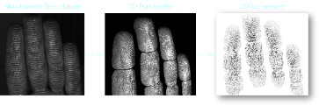
Fig. 8: The founders (from left): Philipp Riehl, Business Development; Daniel Gläsner, Software Strategy; Jörg Reinhold, Managing Director; Dr. Tom Michalsky, Product Development  Filename:  IDloop_10.png | 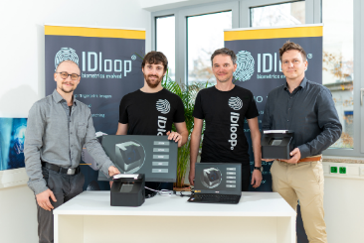

Fig. 9: The 3D fingerprint scanner can significantly speed up clearance in international air traffic.

File name:
IDloop-iStock-879276366-kl

Image rights: Fig. 1 to 8: IDloop GmbH; Fig. 9: iStockphoto/joyt

About IDloop
IDloop GmbH, founded in Jena in 2021, develops systems for contactless fingerprint capture. Even before the company was founded, the four founders had worked together for several years on topics related to biometrics. In the process, they recognized a high potential for the contactless capture of fingerprints.
IDloop has already received several awards for its innovative approach, such as the Pitch Award at the Investor Days Thuringia, the KPMG Audience Award and the Innovation Award Thuringia in the category "Light & Life".
Twelve engineers from various disciplines currently work for the company at its headquarters in Jena.

