Press facts
Hydrogen for the heat treatment of steel
iGas energy: hydrogen for an annealing furnace
Stolberg/Germany, January 28, 2021 iGas energy GmbH has successfully installed an electrolyzer in the new “Miory Steel” tinplate plant in Belarus. The electrolyzer generates up to 100 Nm³ hydrogen per hour for the annealing furnace.
The ‘Green Electrolyzer‘ supplied by iGas energy produces the hydrogen required to anneal the tinplate coils. The plant has a capacity of up to 100 Nm³ hydrogen per hour. The gas processing system achieves a gas quality of up to 5.0, which means a minimum hydrogen content of 99.999 %. Since the gas supply in the new tinplate plant is insufficient, the hydrogen is generated by electrolysis directly on the site. The electricity that is needed to operate the 500 kW electrolysis system is generated in the company's own power plant.
iGas energy delivered the turnkey system in a 12 meter long container in ‘outdoor version‘. Since the gas requirement for the annealing furnace is subject to strong fluctuations, a storage tank was supplied that can hold 50 m³ of hydrogen. Due to the high operating pressure of the Green Electrolyzer of up to 40 bar, the hydrogen can be fed directly into the storage tank without further compression. The hydrogen is then transferred from the storage tank into the plant network. The electrolysis system is operated fully automatically, i.e. the automation system regulates the power requirement and thus the amount of hydrogen produced.
Karl-Heinz Lentz, the founder and managing director of iGas energy, explains why he received the order: “Our customer has chosen the ‘Green Electrolyzer‘ because the operation of the annealing furnace shows strong fluctuations in hydrogen consumption and our PEM electrolyzer can be operated very dynamically. In addition, the overall concept of iGas energy convinced with its low maintenance costs."
The ‘Green Electrolyzer‘ only needs electricity and drinking water to operate. It is particularly suitable for operation at locations where hydrogen is needed but not available. They are also designed for unmanned operation.
320 words including introduction
Background: The PEM technology
The Green Electrolyzers from iGas energy contain electrolysis stacks based on the "Proton Exchange Membrane" (PEM) technology. With an electrical power consumption of 25 kW to 1 MW, the individual stack generates 5 to 210 Nm³ hydrogen per hour. If several stacks are cascaded, they can achieve a connection load of up to 30 MW.
The Green Electrolyzers follow fluctuating power input quickly and work efficiently even in the lower partial load range. You do not need any consumables and the systems are almost maintenance-free.
The innovative thermal management of the modules and the low energy consumption of the ancillary units contribute significantly to the high efficiency of the overall system. The Green Electrolyzers are designed for a service life of more than 20 years and the stacks for more than 80,000 operating hours.
Background: 130 words
About iGas energy GmbH
iGas energy GmbH was founded in 2016 by Karl-Heinz Lentz. The company uses innovative technology to make a contribution to the change in our current raw material consumption economy to achieve a sustainable circular economy.
Today iGas energy is active in three areas:
Hydrogen from renewable energies
Power-to-X systems for storing renewable energy by converting it into hydrogen using high-pressure PEM electrolysis.
Hydrogen-based energy storage
Energy storage systems as a complete solution including energy and heat management, e.g. for energy self-sufficient, CO₂-free neighbourhood solutions and for refueling hydrogen-powered vehicles.
Hydrogen from organic waste
Biogenic processing of organic waste with complete recovery of all valuable materials as well as the production of hydrogen.
iGas energy is part of the Schmidt Kranz Group and uses a wide range of synergies in cooperation with the sister companies, for example in automation, rectifier and high-pressure technology.
Contact:  iGas energy GmbH  Karl-Heinz Lentz  Cockerillstraße 100  52222 Stolberg/Germany  Fon: +49.2402.9791601  www.iGas-energy.de  kh.lentz@igas-energy.de | Editorial contact:  VIP Kommunikation  Dr.-Ing. Uwe Stein  Dennewartstraße 25-27  52068 Aachen/Germany  Fon: +49.241.89468-55  www.vip-kommunikation.de  stein@vip-kommunikation.de

Figures
Download of high resolution photos: press photos
Fig. 1: The Green Electrolyzer was assembled in Germany and delivered turnkey in a 12 m long container in an outdoor version  File name: Green Electrolyzer 500 kW (Belarus).JPEG | 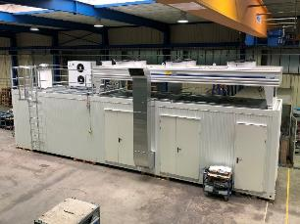
Fig. 2: A Green Electrolyzer with three PEM stacks for the generation of up to 100 Nm³ hydrogen per hour  File name: Green Electrolyzer 12 m.png | 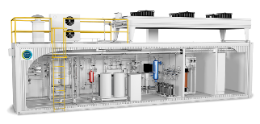
Fig. 3. Container with a length of 12 m on the way to Belarus  File name: Green Electrolyzer on truck.JPG | 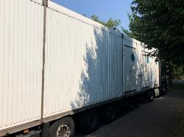
Fig. 4. Inside view of the container  File name: Green Electrolyzer 500 kW inside view.jpg | 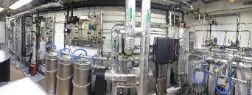

Fig. 5. Karl-Heinz Lentz is not only the founder of iGas energy, he also developed the 'Lentz process', in which valuable materials are extracted from organic waste.

File name: Chief executive officer Karl-Heinz Lentz.JPG
Image credits: iGas energy GmbH

