Micro-lens arrays for optical switches in telecommunications and data-center networks
INGENERIC: Perfecting the art of fiber collimation with micro-lens arrays
Technology demonstrator for micro-lens arrays facilitates testing in your own optical systems
Aachen/Germany, August 31, 2021—Precision collimator arrays for optical switching architectures are increasingly common, for example in telecommunications and hyperscale data-center networks. In order to give developers the opportunity to sound-out the potential of this technology, INGENERIC now presents a micro-lens array (MLA) as a demonstrator, which interested parties can request from the company.
In long-haul and metro networks, “all-optical” switching and routing functions offer considerable advantages. Compared with optical-electrical-optical (OEO) switching, they enable significantly higher Internet bandwidths and shorter latency times.
One example is the wavelength-sensitive switch, which handles the multiplexing, switching and re-multiplexing in third-generation Reconfigurable Optical Add-Drop Multiplexing (ROADM) systems. The basic building blocks of these switches are usually one-dimensional micro-lens arrays that couple the light signals into the output fiber arrays.
Helping developers to test this technology in their own optical systems under practical conditions, INGENERIC has developed a one-dimensional (1D, 1×16) micro-lens array available on request from INGENERIC.
Dr. Stefan Hambücker, Managing Director of INGENERIC GmbH, explains why he is making the demonstrator available to a wide range of users: “While we develop many of our projects closely with customers—with the corresponding confidentiality clauses in place—we are for the first time introducing the MLA demonstrator, a micro-lens array that developers can very easily integrate into their optical systems. It is easy to order from our website with just a few clicks.”
In addition to the demonstrator, interested parties can request the white paper “Perfecting the art of fiber collimation with micro-lens arrays” with extensive technical data and the results from detailed measurements on the INGENRIC website (https://fiber-collimator-array.ingeneric.com/), or get in touch with the INGENERIC specialists online.
The MLA demonstrator is a one-dimensional, plano-convex 1×16 MLA that INGENERIC produces using precision glass molding. It couples light signals in free space or with an intervening glass spacer in fiber arrays. Reference marks minimize the time required for alignment and pre-adjustment in optical systems.
From demonstrator to series
Users who are convinced of the benefits can contact INGENERIC and discuss their individual requirements with the engineering team. This can include, for example, the design of transition zones or the selection of the most suitable glass. Immediately after order placement, INGENRIC begins with the production of the molds and the first prototypes, right up to serial production.
370 words with header

The advantages of precision glass molding for micro-lens arrays
- Significant cost savings through high mold reproducibility
- Low beam-direction errors and high coupling efficiency due to extremely small pitch errors
- High focal-length uniformity due to small radius errors
- Low optical losses due to minimal mold defects and low surface roughness
- Minimal crosstalk of the signals due to negligible dead zones between the lenses
Typical applications for fiber collimator arrays
- Optical switching in free space:
  - Coupling of signals in single- and multimode fibers used at wavelengths commonly used in telecommunications
  - Switching in data centers and telecommunications networks, for example with wavelength-selective switches (WSS)
- Optical free-space communication systems:
  - Coupling of light signals between optical fiber arrays and other components in free space
- Reconfigurable optical add-drop multiplexing (ROADM) systems:
  - Optical components for signal multiplexing/demultiplexing
  - Optical transmission in long-distance, metro and access networks with mesh topographies
Contact:  INGENERIC GmbH  Christina Ferwer  Zum Carl-Alexander-Park 7  52499 Baesweiler/Germany  Tel. +49 2401 804-70400  www.ingeneric.com  ferwer@ingeneric.com | Press contact:  VIP Kommunikation  Dr.-Ing. Uwe Stein  Dennewartstraße 2527  52068 Aachen/Germany  Tel.: +49 241 89468-55  www.vip-kommunikation.de  stein@vip-kommunikation.de
Images
Download high-resolution images: Press photos INGENERIC
Image 1a: The MLA demonstrator is a one-dimensional, plano-convex 1×16 MLA that INGENERIC produces using precision glass molding.
File name:
Ingeneric_JB88878.jpg
Image 1b: The MLA demonstrator is a one-dimensional, plano-convex 1×16 MLA that INGENERIC produces using precision glass molding.  File name:  Ingeneric_JB88878_a.jpg | 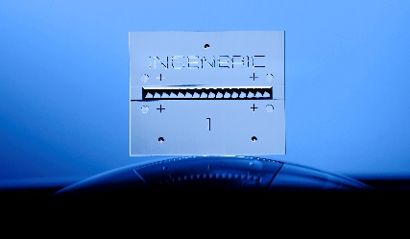
Image 1c: The MLA demonstrator is a one-dimensional, plano-convex 1×16 MLA that INGENERIC produces using precision glass molding.
File name:
Ingeneric_JB88832.jpg
Image 2: One-dimensional MLAs are the basic building blocks for optical switches that are used, among other things, in ROADMs  File name:  Fig01_WSS_Basic_Architechture.jpg | 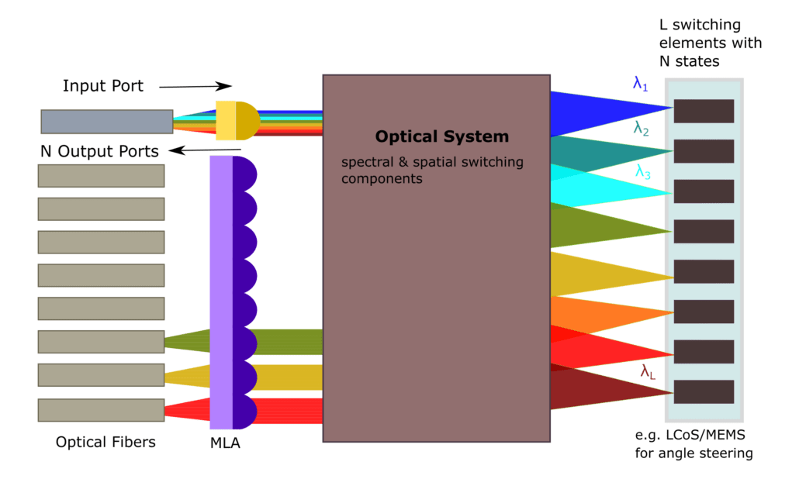
Image 3: The MLA demonstrator has control points for easy alignment and pre-adjustment  File name:  Ingeneric_MLA_Demonstrator.jpg | 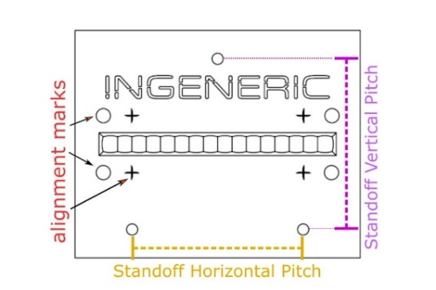
Image 4: The QR code for the download
File name:
Ingeneric_qr-code.jpg
Copyright: Ingeneric
About INGENERIC
INGENERIC develops and manufactures optical components for high-power applications as well as optical systems for research, medicine, measurement technology, and various branches of industry.
The company was founded in 2001 and today employs around 100 people. In 2019 INGENERIC merged with Aixtooling, a manufacturer of tools for precision optics.
For its worldwide customer base INGENERIC offers the complete process chain, from lens and system design, to prototyping, small-scale production, and even mass production.
The following products are manufactured: Fast and slow axis collimation, collimation modules, beam-shaping optics, micro-lens arrays, aspheres, acylinders, and free-form optics.
With its unique technology profile, INGENERIC has become a leading provider of beam-shaping optics for semiconductor lasers. The high-precision micro-lenses are used in growth markets such as medical technology (endoscopy) and optical data communication.

