Press Facts
Dust pollution at the workplace
Jung Instruments: Ensuring dust limits at the workplace
New sampling system determines the inhalable dust content and the respirable dust fraction that may reach the alveoli.
Viersen, Germany, 17 January 2019 The new stationary tester VC25 JI developed by Jung Instruments measures particulate matter and the total dust content at workplaces. A new sensor, manufactured exclusively for Jung Instruments, takes precision of flow rate measurement to the next level. The instrument complies with all commonly applied standards as it uses proven, IFA-licensed sampling heads.
Dust pollution legislation requires that in order to comply with dust limits at workplaces the dust content measurement has to be carried out with appropriate precision right next to the workers or directly at the emission source.
Jung Instruments’ new VC 25 JI dust collection system is a stationary sampling unit designed for the measurement of the dust load at workplaces, such as workplaces for welders, or of the kind found at mixing and filling plants in a wide range of industries.
The system measures the inhalable dust content (specified in IFA standard 7284) and the respirable fraction that may reach the alveoli (specified in IFA standard 6068) according to EN 481, using sampling heads for dust and particulate matter licensed by the German IFA Institute for Work Safety.
Central elements of the new instrument are the robust high-precision flow rate meter, manufactured exclusively for Jung Instruments, and the new, extremely user-friendly electronics. The electronic system is designed to always keep the flow rate at exactly 22.5 m³/h, independent of any ambient temperature or flow resistance variations. The instrument comes with a software for self-diagnosis to monitor the filter condition. Fault messages, e.g. about an obstructed or defective filter, are indicated on the LCD.
Thus the instrument combines new technology for controlling the flow rate and for facilitating handling with tried and tested methods for dust measurement.
According to Erwin Jung, founder and managing director of Jung Instruments, his customers benefit not only from the new technology of the instrument: “Many companies use dust sampling systems that have already reached their economic end of life, but not so the measuring heads that work with the samplers. The new VC 25 JI is the solution many operators have been waiting for: They can now continue using the existing measuring heads.“
The cartridges accommodating the flat filters are easy to handle and can be conveniently taken or shipped to a laboratory for subsequent gravimetric and chemical analyses.
380 words including introduction

About Jung Instruments
Jung Instruments GmbH, founded in 2008, develops and manufactures measuring instruments for the foundry industry. Within its product range, the company specializes in standard-conforming moulding sand testers. The instruments conform to BDG guidelines.
Jung Instruments not only manufactures instruments, but also offers a wide range of comprehensive services, including on-site maintenance and servicing activities. The company calibrates its instruments by means of gauges calibrated by the German Calibration Service (DKD). It is accredited to issue calibration certificates.
The company is certified to ISO 9001:2015.
It has seven employees at its headquarters in Viersen.
Contact:  Jung Instruments GmbH  Erwin Jung  Industriering 52  D-41751 Viersen/Germany  Fon: +49 2162 26 64 790  Fax: +49 2162 26 64 798  www.jung-instruments.de  info@jung-instruments.com | Press contact:  VIP Kommunikation  Dr.-Ing. Uwe Stein  Dennewartstraße 25-27  D-52068 Aachen/Germany  Fon: +49.241.89468-55  Fax: +49.241.89468-44  www.vip-kommunikation.de  stein@vip-kommunikation.de

Figures:
Link for downloading image files in print quality: Illustrations Jung
Fig. 1: The new stationary tester VC25 JI equipped with a sampling head for particulate matter.  File name:  Jung-Instruments-2018-12-VC25-J1-a_771x871.jpg | 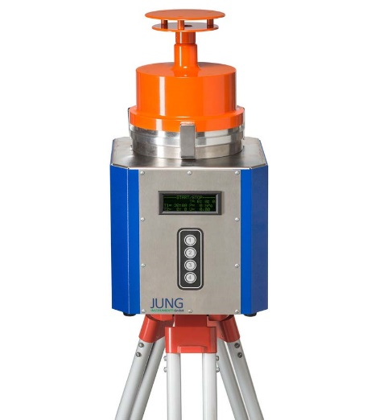
Fig. 2: The new stationary tester VC25 JI equipped with a sampling head for dust.  File name:  Jung-Instruments-2018-12-VC25-J1-b.jpg | 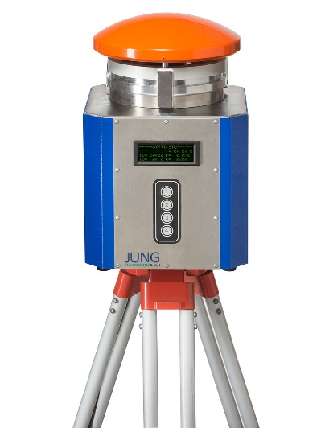
Photos provided by Jung Instruments

