Press Information
Optical inspection of components containing microfeatures

MABRI.VISION:
100-percent component inspection with microscopic resolution
New inline microscope inspects at production speed
Aachen, Germany, March 30, 2023 The new MICRO.SPECTOR from MABRI.VISION scans the complete surface area of components at resolutions smaller than 1 µm. Thus, the system can reliably detect the smallest shape deviations, inclusions or particles in microstructures. Its extremely high operating speed allows the system to be integrated into production lines and scan the products’ entire surface area at the pace of production.
While the visual inspection of a miniaturized component by means of traditional microscopes can take several hours, depending on the complexity of the part, the MICRO.SPECTOR can perform this task, including result evaluation, in a matter of seconds. This capability makes the system suitable for being integrated into production processes and performing 100-percent surface inspections fully automatically.
Typical applications of the new high-speed microscope are components of up to 300 mm x 300 mm size with features in the micro-range. For example, on injection moulded parts with geometrical features measuring between 10 to 50 µm, the system detects form defects, such as excess material, fins or necking. For manufacturers of products that contain elements with microfluidic functions, it is essential that these flaws are reliably detected to guarantee that the elements work as intended. In the manufacturing of screens and high-precision metallic components, the system detects even the smallest form deviations. The MICRO.SPECTOR is also suitable for performing inspection tasks under cleanroom conditions. Here, it can be used to capture scratches on semiconductor elements or inclusions in wafers or processors.
The measuring process is completely integrated into the manufacturing process and performed fully automatically: A sliding carrier feeds the components into the measuring cell at the pace of production for the camera to scan the surface. The carrier travels at speeds of up to 40 mm/s below the stationary lighting and camera unit. At, let’s say, a resolution of 0.75 µm and about 18,000 pixels per line, the system would successively capture the surface in stripes of about 13 mm that the software combines into a complete picture.
The measurement takes just a few seconds to be completed. The sliding carrier moves out of the measurement cell, with the measurement result, “OK” or “not OK”, being instantly indicated on the HMI. The high processing speed and the parallelized processing of the data enables the MIKRO.SPECTOR to achieve cycle times of less than 30 seconds, depending on the component size.
Dr. Ulrich Marx, one of the two Managing Directors of MABRI.VISION, says: “We see a growing trend towards increasing miniaturization in many industrial sectors. In quality control, the application of classical image processing has so far concentrated on objects of larger dimensions. With our innovative approach, we are now not only entering the world of microscopic surface inspection, but also supplying systems that can operate at the pace of production. This, of course, calls for sophisticated software. But, utmost mechanical precision to ensure that the item to be measured and the camera are accurately positioned, and excellence in interface expertise to enable smooth integration into the customer’s process control system are just as important. All these features have been implemented in our MICRO.SPECTOR system.”
520 words including introduction
Contact:  MABRI.VISION GmbH  Dr. Nicolai Brill, Geschäftsführer  Philipsstraße 8  D-52068 Aachen/Germany  Phone: +49 241 56527930  www.mabri.vision  sales@mabri.vision | Contact for the media:  MABRI.VISION GmbH  Martin Isserstedt, Marketing  Philipsstraße 8  D-52068 Aachen/Germany  Phone: +49 151 42053001  www.mabri.vision  martin.isserstedt@mabri.vision
Photo credits: MABRI.VISION GmbH

Figures and captions:
Link for downloading image files in print quality: press photos
Fig. 1: The new MICRO.SPECTOR from MABRI.VISION scans the complete surfaces of components with resolutions smaller than 1 µm.  File name:  MabriVision_TDI-Kamera_mit_Beleuchtung.jpg | 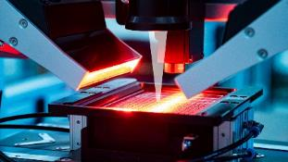
Fig. 2: By means of Z autofocusing, the MICRO.SPECTOR also captures nonplanar features.  File name:  MabriVision_Z-Fokus-Topographie.jpg | 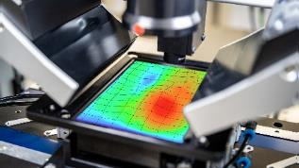
Fig. 3: The camera scans the component travelling below the stationary lighting and camera unit in meandering movements at speeds of up to 40 mm/s.  File name:  MabriVision_Abblasvorrichtung.jpg | 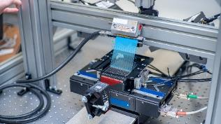
Fig. 4: Sitting on sliding carriers, the components are fed into the measuring cell and inspected.  File name:  MabriVision_EYE_MI1-Volumen.jpg | 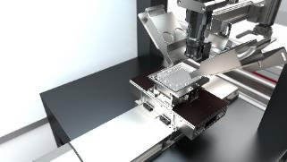
Fig. 5: The MICRO.SPECTOR is designed to operate within a fully automatic production environment in clean rooms.  File name:  MabriVision_MICRO-SPECTOR-MI1.png | 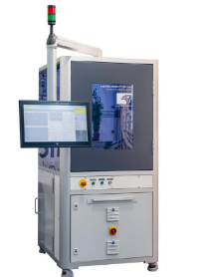
Fig. 6: Necking in a microfluidic device  File name:  MabriVision_Mikrofluidik-Dünnstellen_2.jpg | 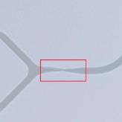
Fig. 7: Inclusions in a microfluidic device  File name:  MabriVision_Mikrofluidik-Einschlüsse.jpg | 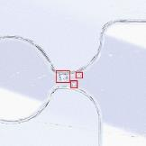
Fig. 8: Scratches on a microfluidic device
File name:
MabriVision_Mikrofluidik-Kratzer.jpg
Fig. 9: Injection-moulded microfluidic device with cavity filling defect.  File name:  MabriVision_Mikrofluidik-Spritzfehler.jpg | 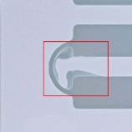
Fig. 10: Dr. Ulrich Marx (left) and Dr. Nicolai Brill founded MABRI.VISION GmbH in the German city of Aachen, an international technology hub.
File name:
MabriVision_Brill_Marx_4.jpg
Image rights: MABRI.VISION GmbH

About MABRI.VISION
Dr. Ulrich Marx (left) and Dr. Nicolai Brill founded MABRI.VISION GmbH in 2015. The company, located in the German city of Aachen, a renowned international technology hub, develops, manufactures and supplies optical sensors and turn-key inspection systems for offline and inline quality control in industrial production environments.
On the premises of the former Philips bulb factory, the currently 35 employees of the company are engaged in the development and production of innovative optical measuring systems.
MABRI.VISION supplies its products to customers in industries such as packaging technology, automotive, metals processing, electronics and medical engineering.

