Press facts for METEC 2023
Quality assurance at the hot forging press
nokra: Micrometer-accurate prediction of cold dimensions in a matter of seconds after forging
Laser measures the entire 3D contour of forging specimens up to 1,200°C hot
Baesweiler, Germany, March 9, 2023 At METEC 2023, nokra will be showing for the first time its new alpha.hot3D system for 3D laser-based measurements of hot forging specimens. The system can predict the cold dimensions of a forged part in a matter of seconds after forging. This makes it possible to verify as early as the first few parts have been produced that the forming process is working without a hitch. If it is not, you can immediately take measures to adjust it.
The sooner you can be sure that the parts you are forging will comply with the cold dimensions specified, the higher the efficiency of the forging line will be. So far, operators had to wait up to two hours – depending on the component size – for a forging specimen to cool down to a sufficiently low temperature to be able to measure its cold dimensions in a coordinate measuring system.
By that time, modern hot forging presses could - in the worst case - have produced thousands of out-of-spec forged parts.
In contrast, nokra’s new alpha.hot3D system can measure parts up to 1,200°C hot, capturing their entire contour and calculating their cold dimensions with an accuracy down to ± 25 µm. Consequently, the system makes it possible for the operator to adjust the forging process in a matter of seconds after the first part has been formed.
Thanks to its compact design, the system can be installed right on the working platform of a forging press. The hot forged parts are picked up from the conveyor belt as they leave the forging press and directly placed into the measuring cell. The measurement is started with the press of a button. The “within specs” or “out of specs” result of the cold-dimension calculation, including a display of the component characteristics and a target/as-is comparison, is available within just a few seconds. After the measurement, the forging specimen can be returned to the process flow.
The system passed the acid test measuring rotationally symmetrical components produced by a hot forging press. The cold dimensions calculated by alpha.hot3D were compared with those measured with a coordinate measuring system. The results differed by only between 5 and 20 µm – much less than the operator expected.
Günter Lauven, Managing Director of nokra GmbH, sees great potential for the new system: “The investment pays off quickly, in particular when being used with smaller batches where any irregularity of the dies has quite an impact. Performing measurements at regular intervals during production, moreover, provides additional confidence and process security.”
420 words including introduction
The technology in detail
alpha.hot3D measures the entire 3D contour of hot components. Up to four nokra laser light-section sensors capture the 3D geometry while the hot component is rotating through 360° in the measuring cell. A further sensor is provided for measuring the component temperature.
From the contour values measured, various algorithms calculate the geometrical characteristics specified. The cold dimensions of the forging specimen are calculated by a dedicated algorithm based on the measured temperature. As the system is being trained for each individual forging type to be measured, the calculation of the cold dimensions is always adapted to the specific component and its features. The algorithm does not only use the typical thermal expansion coefficient of the alloy in the calculation, but also takes into account the component shape and the fact that some areas may cool down faster than others.
The first system built is designed for a maximum component size of 130 mm x 115 mm. The highly compact benchtop system can be conveniently set up on the working platform of the press. Systems for component sizes up to 185 mm x 190 mm are in preparation.
Technology in detail: 180 words
nokra at METEC 2023
Düsseldorf, Germany, 12 to 16 June 2023
Hall 1, Stand B29
Contact:  nokra Optische Prüftechnik und Automation GmbH  Günter Lauven  Robert-Koch-Straße 6  D-52499 Baesweiler/Germany  Phone: +49 2401 6077-0  www.nokra.de  glauven@nokra.de | Press contact:  VIP Kommunikation  Dr.-Ing. Uwe Stein  Dennewartstraße 25-27  D-52068 Aachen/Germany  Phone: +49 241 89468-55  www.vip-kommunikation.de  stein@vip-kommunikation.de

Figures and captions
Link for the download of images in printable quality:
Click here: press photos nokra

Fig. 1: The hot forged parts are picked up by a conveyor belt as they leave the forging press and directly placed into the measuring cell.  File name:  nokra_Messzelle-für-warme-Schmiedeteile-kl.jpg | 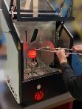
Fig. 2a: During the measurement, the forging is rotated by a turntable.  File name:  nokra Laser Vermessung warmes Schmiedeteil.jpg.jpg | 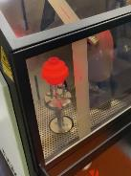
Fig. 2b: During the measurement, the forging is rotated by a turntable.  File name:  nokra Laser Vermessung warmes Schmiedeteil nah.jpg | 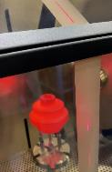
Fig. 3: A digital twin of the forging is generated based on the contour data measured.  File name:  Nokra_Digitaler_Zwilling_Schmiedeteil_schräg.png | 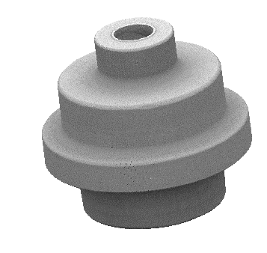
Fig. 4: The results are displayed in a matter of seconds.  File name:  Nokra-2022-06_01d.jpg | 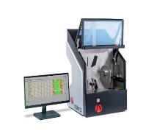
Image rights: nokra GmbH
About nokra
nokra GmbH is an international business specialized in high-end measuring and testing equipment for the manufacturing industry. nokra systems measure and inspect geometrical features such as length, width, thickness, flatness, profile, shape and position.
nokra develops and manufactures the automated inspection systems and the laser sensors for the systems in-house. This enables nokra to easily optimize a standard system for the specific use case on hand. The company builds on comprehensive expertise from a wide range of projects addressing measuring tasks in the steel, aluminium, automotive supplier, plant engineering and automotive glazing industries.

