Press facts for METEC 2019
Optical measuring technology for strip and plate
nokra: Laser-optical crossbow measurement optimizes stretch-leveler performance
Baesweiler, Germany, 23. April 2019 At METEC, nokra will launch its new alpha.cb laser-optical system for the measurement of crossbow in strips. The new system can be used, among others, for optimizing the control of stretch-levelers. The company’s further exhibits will include optical gauges for combined inline measurement of thickness, flatness and contour of plates as well as for high-precision strip thickness measurements.
The new system measures crossbow of strip in an inline process. The results from the measurements can be used to optimize stretch-leveler control so as to minimize crossbow formation. With processes becoming increasingly digitally interlinked, the measurement data can also be used to optimize up and downstream processes – such as hot and cold rolling - by analyzing whether and where cooling strategies or coiling methods may promote crossbow formation.
The system operates according to the light-section method, which uses laser lines projected onto the strip surface. The measuring frame, which accommodates the transmitter and receiver optics, is low enough to not interfere with the movements of the hall crane. At the same time, the optical equipment is arranged at a safe distance from the strip surface, ruling out any risk of mechanical damage. The system requires no compressed air and no water cooling.
It measures height at an accuracy of 0.1 mm. Together, the two cameras of the system capture approximately 3,200 pixels across the strip width. For a 1,800 mm wide strip, this means a transverse resolution of 0.6 mm.
For plate rolling mills, nokra will show laser-optical gauges for the combined inline measurement of flatness, thickness and contour. The sensor equipment for these measurements has been arranged within a very compact system. These gauges are often used in plate mills at the hot rolling stands to monitor the rolling process, in downstream process stages, for example, at cold leveling machines, and for quality inspection of the finished plates.
Also on display at METEC will be nokra’s alpha.ti 4.0 system, a laser-based, non-contact gauge for high-precision strip thickness measurements. The gauge operates at a measuring accuracy of 0.01% of the measuring range, i.e. over 15 mm the accuracy is +/- 1.5 µm. It features an automatic monitoring function that makes it MSA-compliant.
360 words, including the introduction
nokra at METEC 2019
Düsseldorf, Germany, 25 to 29 June 2019:
Hall 5, stand F20
Contact:  nokra Optische Prüftechnik und Automation GmbH  Günter Lauven  Max-Planck-Straße 12  D-52499 Baesweiler/Germany  Fon: +49.2401.6077-10  www.nokra.de  glauven@nokra.de | Press contact:  VIP Kommunikation  Dr.-Ing. Uwe Stein  Dennewartstraße 25-27  D-52068 Aachen/Germany  Fon: +49.241.89468-55  www.vip-kommunikation.de  stein@vip-kommunikation.de

Figures and captions
Link for downloading image files in print quality:
click here: press photos nokra

Fig. 1a: Each of two lasers projects a line onto the strip surface; matrix cameras arranged at an angle capture the position of the lines on the strip.  File name:  nokra 10468-Querbogenmessung-02.jpg | 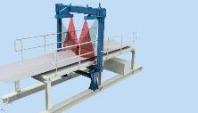
Fig. 1b: Each of two lasers projects a line onto the strip surface; matrix cameras arranged at an angle capture the position of the lines on the strip.  File name:  nokra 10468-Querbogenmessung 01.jpg | 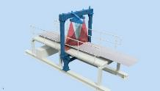
Fig. 2: A system at the continuous pickling line entry installed between the bridle roll and the process section.  File name:  nokra szag_017_8573a.jpg | 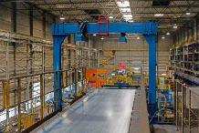
Fig. 3: A system arranged at the continuous pickling line exit.  File name:  nokra szag_020_8582a.jpg | 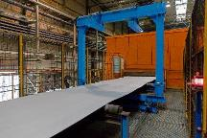
Fig. 4: The two laser lines projected across the running strip are offset in order to avoid cross-talk between the two channels.  File name:  nokra szag_026_8602.jpg | 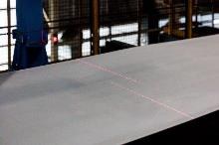
Photo credits: Fig. 1: nokra, Fig. 2 – 4: Salzgitter Flachstahl GmbH
About nokra
nokra GmbH is international medium-sized business specialized in high-end measuring and testing equipment for the manufacturing industry. The systems measure and test geometric features such as length, width, thickness, profile, shape and position.
nokra itself develops the laser sensors and automated inspection systems for its systems. This enables nokra to customize every system to the specific requirements of its clients and optimize it for the respective application. The company builds on comprehensive experience from a wide range of projects addressing specific measuring application in the steel, aluminum and automotive industry as well as glass processing, plastics industry and plant engineering.

