Press information for METEC 2023
Velocity and length measurement in strip rolling and processing lines

Polytec:
Enhanced connectivity facilitates integration into process control
New Laser Surface Velocimeter ready to be integrated into various production environments.
Darmstadt, March 31, 2023 At the Metec trade fair, Polytec will be showing its new ProSpeed® LSV-1100 Laser Surface Velocimeter. Designed for enhanced connectivity and easy integration into process control, the new system model boasts the same technological level as its big brother ProSpeed® LSV-2100. The high-precision velocity and length measurements provided by the system help operators to improve the quality of their products, increase the efficiency of material use and achieve a higher yield, for example, by using them for mass flow control and cut-length optimization.
In rolling mills and strip processing lines, the high-precision speed and length data provided by the surface velocimeters of the ProSpeed® LSV series are used as input data for process control and process optimization.
The new ProSpeed® LSV-1100 comes with the same connectivity as the ProSpeed® LSV-2100, the most comprehensive system of the series and designed, for example, to operate from larger stand-off distances. Both Polytec systems now feature various interfaces, e.g. for Profinet or Ethernet connectivity, to facilitate their integration into modern process control environments. The wide range of available interfaces makes it easy for plant engineers to integrate the system into the data environments of production plants, no matter where in the world they are going to be used.
The measured data can be transferred via a wi-fi module to the control pulpits and visualized. The display of the data can be freely configured and the measured values conveniently parameterized and maintained via a web interface. Up to four users can access the system data at the same time.
By providing the new ProSpeed® LSV-1100 with the same high connectivity level as the ProSpeed® LSV-2100, Polytec makes operation and maintenance of the systems across the works easier. Both systems have the same high technological standard and are operated and maintained exactly in the same way. This is a great benefit for plant operators using both series models in their operations.
Robert Bodamer, Product Manager at Polytec, describes how his customers benefit from this standardization: “The two systems differ only in terms of the measuring features and the way they can be arranged in the production line. ProSpeed® LSV-2100, for example, comes with the additional capability of detecting the product‘s direction of motion and even standstill conditions. And it can be arranged at stand-off distances of up to 3 meters from the passline.”
Surface velocimeters are used for process control functions such as mass flow regulation (Automatic Gauge Control AGC) at rolling stands. The data from the strip speed measurement play a key role in speeding up and making roll gap adjustment more precise. Thus, AGC reduces the time needed for a strip to achieve its specified thickness after coil threading, reducing the out-of-spec portion of the coil as a result.
450 words
Polytec at Metec 2023
Düsseldorf, Germany, June 12 – 16, 2023
Hall 1, Stand A54
Contact:  Polytec GmbH  Business Unit Optical Measurement Systems  Robert Bodamer  Product Manager LSV  Polytec-Platz 1-7  D-76447 Waldbronn/Germany  Phone: +49 7243 604-1750  www.polytec.com  r.bodamer@polytec.de | Contact for the media:  VIP Kommunikation  Dr.-Ing. Uwe Stein  Dennewartstraße 25-27  D-52068 Aachen/Germany  Phone: +49 241 89468-55  www.vip-kommunikation.de  stein@vip-kommunikation.de
Figures and captions
High-resolution image files are available to download at: Pressefotos Polytec
Fig. 1: The new ProSpeed® LSV-1100 Laser Surface Velocimeter comes with the same wide range of interfaces as its “big brother”, making the integration of the system into different process control environments extremely easy.  File name:  Polytec_Konnektivität.jpg | 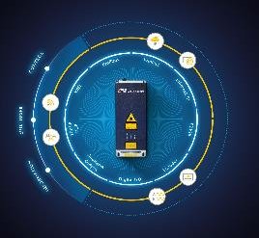
Fig. 2: A Laser Surface Velocimeter used at a strip rolling stand for mass flow regulation  File name:  Polytec_Massenflussregelung.jpg | 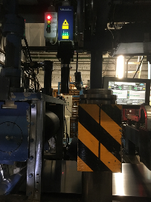
Fig. 3a: The ProSpeed® LSV-1100 Laser Surface Velocimeter measures speed and length during strip rolling and processing.  File name:  Polytec_LSV-1100.jpg | 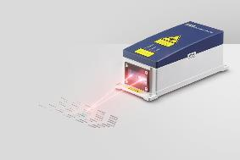
Fig. 3b: The ProSpeed® LSV-2100 Laser Surface Velocimeter additionally recognizes the direction of the product’s motion and standstills.  File name:  Polytec_LSV-2100.jpg | 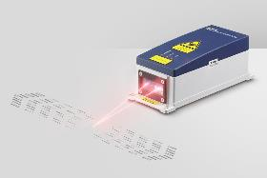
Fig. 4: Polytec provides an extensive range of accessories to ensure that the sensor is perfectly adapted to the specific rolling mill environment. The picture shows a velocimeter with a protective, insulating housing on an adjustable mounting base.  File name:  Polytec_LSV with TPH.jpg | 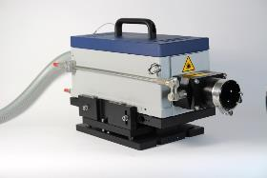
Image rights for figures 1, 3 and 4: Polytec GmbH; for figure 2: C.D. Wälzholz GmbH & Co. KG
About Polytec
Pioneers in laser technology, Polytec has been supplying solutions for optical measurement tasks in R&D and industry since 1967. Following the first years in business as distributors, the German high-tech company, based in the town of Waldbronn near Karlsruhe, made its name in the 1970s as a developer and engineer of laser-based measuring systems. Today, the company’s extensive range of proprietary products includes laser vibrometers, optical surface metrology systems, systems for process analytics and process automation. Especially, Polytec’s Laser Surface Velocimeters (LSV) have become established in the metals industry as reliable systems that measure length and product speed with the highest precision.

