Press Facts: Formnext 2021
Metallic materials for Additive Manufacturing

ponticon:
Screening hundreds of new alloy variants in one day
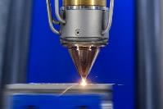
New technology accelerates the development of new alloys for Additive Manufacturing
Wiesbaden, Germany, Oktober 5, 2021 At Formnext, Ponticon is going to showcase pontiMAT, an innovative process that supports the development of metallic alloys for use in AM. Never before has it been possible to produce and test samples of alloy variants of such wide range in such short time.
With pontiMAT, samples of application-specific materials can be produced and tested at unprecedented rates using minimum resources. The system is extremely versatile in terms of the types of metallic alloying elements it can use. This flexibility and its capacity to adjust the cooling rates finely and with high precision make pontiMAT the system of choice especially for developers of innovative materials for AM applications.
The new system is based on the EHLA-3D technology, an extremely high-speed laser deposition welding process conceived and developed into a market-ready product by ponticon in close cooperation with the Fraunhofer Institute for Laser Technology ILT, based in Aachen, Germany, and the Chair for Digital Additive Production (DAP) at RWTH Aachen University.
In addition to being able to combine an extremely wide and diverse range of alloying elements, the pE3D system employed enables the molten material to solidify at specific rates within a very wide range, namely from 100 K/s to 10 million K/s. Thus, the microstructural features can be influenced within unprecedented limits.
The system can be very helpful in and speed up the development of alloys for specific applications. Here, it can be used to produce 3D-printed samples, e.g. of one cubic centimeter for metallurgical analysis in virtually no time, enabling hundreds of alloying variants per day to be processed into samples and tested. Thus, the new system dramatically reduces the effort otherwise involved in conventional sample melting and analysis methods.
According to Tobias Stittgen, Managing Director of ponticon GmbH, his customers benefit in multiple ways: “From a design perspective, many components are designed and optimized for their suitability for Additive Manufacturing even today. However, the optimization of the materials has a significantly higher potential for functionality enhancement. When our customers use our pontiMAT system in the development of new, application-specific AM alloys, they can achieve some 50 percent performance improvement from their products - not just five or ten percent.”
370 words
ponticon at Formnext 2021:
Exhibition grounds Frankfurt/Main, Germany,
from November 16 to 19, 2021
Hall 12, Stand A01C
The EHLA process in detail
In contrast to conventional laser deposition methods, in the EHLA process the metallic powder is melted before it reaches the surface of the substrate on which it is deposited in successive layers.
A central element of the system is the laser head with the integrated powder nozzle. The head is thus designed so the light emitted by a laser of several kW capacity is focused a few millimeters above the surface. The metallic powder is fed into the laser beam by means of a nozzle specifically designed for the EHLA system. Different alloying materials can be mixed in virtually any combination. For this, up to eight powder feeders are available for up to eight different metallic elements or pre-blended alloys. This makes the system particularly suitable for systematic analysis and testing of high-entropy alloys and their specific properties. Because of their capacity to adopt virtually any material properties imaginable, these alloys are of great interest to materials scientists.
In order to achieve high relative velocities between the printing head and the printed component, the head, including the laser optics and the powder nozzle, is fix-mounted, while the plate that serves as the substrate for the printed component is arranged on a movable tripod below the nozzle. The linear kinematics - specially designed for this process - makes it possible to achieve very high acceleration rates and process speeds while still printing with the highest precision.
Operation of the pE3D system necessitates extreme mechanical stability. Because of this, the system is mounted on a structure made of 200 mm-thick granite plates surface-ground with a tolerance of just 5 µm.
The printing process is precisely controllable by means of finely adjusted key parameters such as the laser power, laser beam diameter, mass flow of the powder and moving velocity of the substrate carrier.
The EHLA process in detail: 300 words
Contact:  ponticon GmbH  Tobias Stittgen  Alte Schmelze 20  D-65201 Wiesbaden, Germany  Phone: +49 6136 91745010  www.ponticon.de  t.stittgen@ponticon.de | Press contact:  VIP Kommunikation  Dr.-Ing. Uwe Stein  Dennewartstraße 25-27  D-52068 Aachen, Germany  Phone: +49 241 89468-55  www.vip-kommunikation.de  stein@vip-kommunikation.de

Figures and captions
High-resolution image files are available to download at: press photos ponticon
Fig. 1: Samples used in the development of new alloys for specific AM applications.  File name:  Ponticon-Legierungsscreening.JPG | 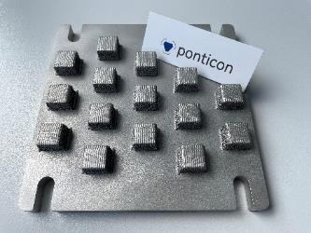
Fig. 2a: The metallic powder, fed by the nozzle integrated within the printing head, melts before it reaches the surface of the substrate material.  File name:  Ponticon-3D-EHLA Prozess.jpg | 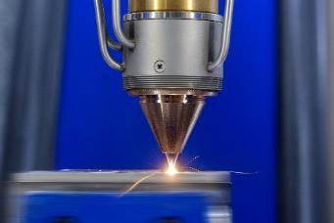
Fig. 2b: The metallic powder, fed by the nozzle integrated within the printing head, melts before it reaches the surface of the substrate material.  File name:  Ponticon-EHLA-Prinzip.jpg | 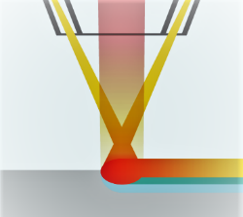
Fig. 3: While the printing head remains in a stationary position, the substrate carrier is moving.  File name:  Ponticon-3D-EHLA.jpg | 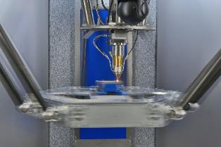
Fig. 4: Arrangement of the pE3D system in use at the Fraunhofer Institute for Laser Technology ILT.  File name:  Ponticon-pE3D.jpg | 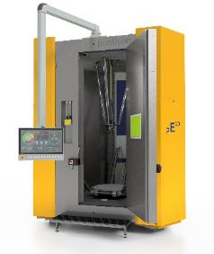
Fig. 5: Blending of the alloy components within the powder nozzle.  File name:  Ponticon-Mischer-Prinzip.png.jpg | 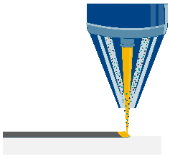
Fig. 6: Up to eight powder feeders are available for up to eight different metallic elements and pre-blended alloys.  File name:  Ponticon-pontiMAT-schematisch.jpg | 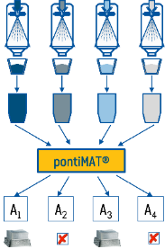
Fig. 7: Tobias Stittgen (left) and Thomas Horr, the two Managing Directors of ponticon GmbH, next to a pE3D system to be presented at the upcoming Formnext exhibition in Frankfurt/Main, Germany.  File name:  Thomas Horr und Tobias Stittgen.jpg | 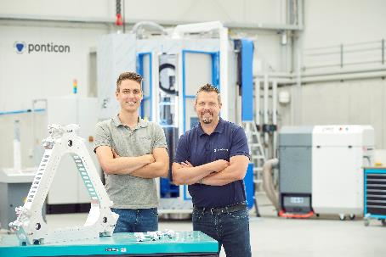
Photos: courtesy ponticon GmbH
About ponticon
ponticon develops and markets systems and solutions for the bonding of materials unsuitable for conventional joining methods.
The high-performance ponticon pE3D system is designed for dynamic, industry-compliant coating, repair and Additive Manufacturing of metal components that have to withstand high in-service stresses. ponticon uses the same basic system in alloys development, expanding the limits of traditional sample testing. Developers of innovative materials for specific AM applications can use the system for the cost-efficient and time-saving production of alloy samples, benefitting from the system’s extreme versatility. It can be used for all variants of laser-based deposition welding from one-offs to series production.

