Press Information
Manufacturing technologies for e-mobility components

Rohmann Automation:
New trade congress “Robotics meets eMobility”
New international congress brings together vehicle and battery manufacturers with leading suppliers of manufacturing technology.
Ingelheim, Germany, May 2, 2023 On June 1, the first edition of “Robotics meets eMobility”, a new trade congress launched by Rohmann Automation, will take place on the company’s premises at the German town of Ingelheim am Rhein. In case studies, leading manufacturers of e-vehicles and e-mobility components will discuss the versatility of robotic solutions in manufacturing processes. Suppliers of manufacturing technologies will demonstrate latest system innovations. The event will be held under the patronage of Mrs. Malu Dreyer, Minister President of the German Federal State of Rhineland-Palatinate.
The transition from the combustion engine to e-mobility is generating enormous upheaval for numerous companies – in terms of both products and the necessary production technologies. Mechanical components are less in demand, electrical ones the more so. This is true of the entire technology chain from component production through to the necessary charging infrastructure.
Robotics are increasingly playing a central role in virtually all production processes: Against international competition, the efficiency of manufacturing determines manufacturers’ competitiveness – especially in high labour-cost countries such as Germany.
The congress at Ingelheim am Rhein will bring together component and vehicle manufacturers with companies that can supply genuinely future-proof solutions.
Vehicle and battery manufacturers such as Stellantis, Gotion and BMZ will be showing systems that are already available and those needed for the manufacturing of the future. On the basis of case studies, companies such as KUKA, Trumpf and YASKAWA will be discussing solutions that increase manufacturing efficiency.
Presentations by leading battery researchers from RWTH Aachen University will disclose details of what the future holds. The keynote lecture by Prof. Detlef Zühlke, the originator of the term “Industry 4.0”, will illustrate the way how the Smart Factory helps in streamlining processes and reducing costs.
Panel discussions will enable attendees to communicate directly with leading experts in the electromobility industry.
Jascha Rohmann, founder and CEO of Rohmann Automation GmbH, commenting on his intention to provide a new joint forum for the players in this key industry: “To ensure that German manufacturers remain at the top, it is vital to concentrate know-how now – to bring together small and large companies in the industry. That is why we are organizing “Robotics meets eMobility 2023”. The congress provides a forum to bring market participants in the electromobility industry and robotics closer together.”
400 words, including the introduction
More information at: www.rohmann-automation.de/robotics-meets-emobility-en
Date and time: June 1, 2023, 9:00 to 18:00 h
Location: Rohmann Automation GmbH
An den Wiesen 10, Ingelheim am Rhein, Germany
Contact:  Rohmann-Automation GmbH  Jascha Rohmann, CEO  An den Wiesen 10  55218 Ingelheim am Rhein/Germany  Phone: +49 6132 8994-980  www.rohmann-automation.de  jascha.rohmann@rohmann-automation.de | Contact for the media:  VIP Kommunikation  Dr.-Ing. Uwe Stein  Dennewartstraße 25-27  52068 Aachen/Germany  Phone: +49 241 89468-55  www.vip-kommunikation.de  stein@vip-kommunikation.de
Figures and captions
High-resolution image files are available to download at:
press photos Rohmann Automation
Fig. 1: “Robotics meets eMobility” provides a forum for manufacturers and suppliers active in the e-mobility market.  File name:  Rohmann_Quadrat.jpg | 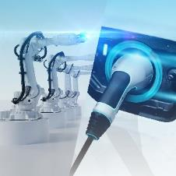
Fig. 2: Automatic depalletizing of battery components, supported by 3D laser scanners  File name:  Rohmann_Bild9a.jpg | 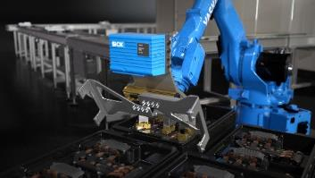
Fig. 3: Laser welding of copper components for sensitive battery management systems  File name:  Rohmann_Bild4.jpg | 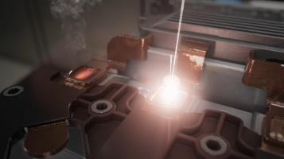
Fig. 4: Particles arising from the welding process are extracted directly where they occur  File name:  Rohmann_Bild5.jpg | 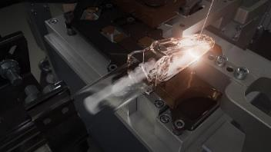
Fig. 5: 3D weld seam inspection with a 3D profile sensor enables automatic quality control  File name:  Rohmann_Bild6a.jpg | 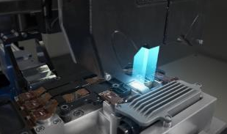
Fig. 6: Robots perform a great variety of component machining and handling tasks  File name:  Rohmann-Bild12.jpg | 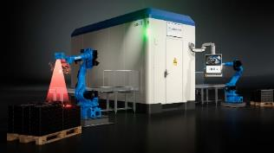
Fig. 7: Jascha Rohmann (center), founder and CEO of Rohmann Automation, explains details of the robot control process  File name:  Rohmann_foto_03.jpg | 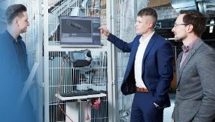
Fig. 8: Robots have become indispensable in electric vehicle production  File name:  Rohmann_foto_01.jpg | 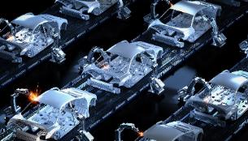
Image rights: Figures 1 to 7: Rohmann Automation GmbH, Figure 8: Freepik Premium
About Rohmann Automation
Rohmann Automation GmbH, founded in 2007, develops, designs and implements automation solutions for industrial manufacturing processes, using innovative robotic systems. The systems supplied by Rohmann Automation range from individual manufacturing cells through to integrated production lines, covering all functional areas from mechanical processes, automated cutting and joining, such as laser welding, via machine vision systems through to quality control and seamless systems and data integration into the manufacturers’ digital environments.
Rohmann Automation focusses on e-mobility and automated depalletizing supported by 3D machine vision systems. The company is renowned for its innovations, such as the new LaserCubeX laser welding cell for copper.
The company’s customer base includes leading companies in the automotive and aviation industries.

