Press Information for METEC/GIFA 2023
Elemental analysis in steel production and processing
Premiere at METEC 2023
Secopta analytics:
Materials analysis from incoming goods inspection down to the finishing stage – fast and precise
Laser-based system speeds up material inspection
Teltow, Germany, March 27, 2023 At METEC/GIFA 2023, Secopta will be showing two new systems – one for time-saving incoming goods inspection and one for speedy, fully automatic inline PMI analyses. With the SlagLIBS system, steelmakers can efficiently check whether incoming deliveries of fluxing material comply with the chemical composition specified. For PMI (Positive Material Identification) of long products, Secopta’s FiberLIBS systems now also come with a measuring head that can be placed on the product, e.g. billets, to perform a PMI analysis before reheating.

Time-saving incoming goods checks with SlagLIBS
At METEC 2023, Secopta will be showing its new SlagLIBS system to the public for the first time. The system can be used in steelworks to analyze e.g. the chemical composition of incoming deliveries of fluxing and alloying agents – in just a few minutes. The system achieves the same high accuracy as an XRF (X-Ray Fluorescence) analysis, which is state of the art, but delivers the analysis results much faster. Thus, incoming material that does not comply with the specifications can be rejected without delay.
The analyses with SlagLIBS require minimum sample preparation. Just a quick size reduction by crushing (between 5 to 15 mm) of coarse material is adequate enough to deliver results with acceptable accuracy. This is possible to achieve within few minutes after sample taking. In contrast, an XRF analysis, including sample preparation, can take up to two hours.

Fully automatic PMI with FiberLIBS
The FiberLIBS systems have already proven their competency in automatic, inline PMI (Positive Material Identification) of finished long steel products, such as bright bar, sections and pipes, that pass the analyzer at speeds of up to 2 m/s.
A novelty – to be unveiled at METEC – is FiberLIBS for PMI of semi-finished products, e.g. billets, retrieved from intermediate storage for subsequent rolling. Performing the PMI analysis before reheating the billet guarantees that only input material with the specified properties is charged into the reheating furnace.
The new FiberLIBS system comes with a specially designed measuring head that is automatically lowered onto the surface of the stationary billet. 'As billets are often stored in the open air, the measuring head has a fully integrated automatic sample preparation technology that removes the scale from the billet surface before the analysis'. The entire process takes just about 30 seconds. Thus, every batch charged is automatically 100% PMI-tested – a distinct advantage over conventional manual testing with a spark spectrometer (OES).
420 words including introduction
Secopta at METEC/GIFA/THERMPROCESS 2023
Düsseldorf, Germany, June 12 – 16, 2023:
Hall 4 / Stand A 23
Contact:  Secopta analytics GmbH  Rheinstr. 15b  14513 Teltow/Germany  www.secopta.de  Dr. Christian Bohling  Phone: +49 3328 35403-11  Email: christian.bohling@secopta.de | Press contact:  VIP Kommunikation  Dennewartstraße 25-27  52068 Aachen/Germany  www.vip-kommunikation.de  Dr.-Ing. Uwe Stein  Phone: +49 241 89468-55  Email: stein@vip-kommunikation.de

Figures and captions:
Link for downloading image files in print quality:
Please click here: press photos Secopta
Fig. 1: The compact SlagLIBS system requires only little space in the lab.  File name:  Secopta_140947.jpg | 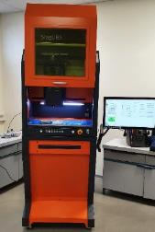
Fig. 2: The sample holder of the SlagLIBS system can be filled with coarsely crushed material of up to 15 mm grain size.  File name:  Secopta_IMG_0456.jpg | 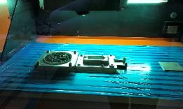
Fig. 3: The FiberLIBS measuring head for PMI analyses before reheating oven is automatically positioned on the surface of the billet material.  File name:  Secopta_183901.jpg | 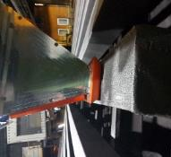
Fig. 4: FiberLIBS removes oxide, carbonization and scale deposits from the billet surface by laser ablation, before it starts the LIBS measurement.  File name:  Secopta_01.jpg | 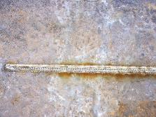

Image rights: Secopta analytics GmbH

About Secopta analytics
Secopta analytics GmbH, based in Teltow near Berlin, offers laser-based analysis solutions for tasks in industrial process control as well as in the production of primary and secondary raw materials.
Application fields for the company’s systems range from extraction and refinement of raw materials to process control in industrial manufacturing to processing of secondary raw materials, environmental analytics and detection of hazardous substances. Secopta develops full-line customized solutions for automated analytical processes, including in-line, on-site and in-situ analyses during running production.

