Press Information for TUBE/WIRE 2022
Inline elemental analysis of metals
First presentation at TUBE 2022
Secopta analytics: Fully automatic inline PMI now also for black steel
Laser-based system enables material testing without separate mechanical sample preparation.
Teltow, Germany, 11 April 2022 At the TUBE/WIRE trade fair, Secopta is going to present its new LIBS system which, for the first time, enables fully automatic inline Positive Material Identification (PMI) testing of long steel products in black condition. With more than 99.9 percent reliability, the system identifies material whose chemical composition is not as specified and removes it from the production process. Thus, the system can be used, for example, to prevent that the wrong semi-finished products are selected for a downstream process.
For bright steel products, fully automatic Positive Material Identification (PMI) testing has already become an established process in many mills. With its FiberLIBS black bar system, Secopta now applies its range of inline LIBS systems for the first time also to black steel products. The laser-based system dramatically reduces the manual effort so far involved in material identification processes, very often even making separate mechanical sample preparation unnecessary.
Secopta has adapted the sample preparation system integrated in their analyzers to the needs of black steel testing. Surface contamination, such as scale, oil and other interfering factors, are removed fully automatically. This makes it possible for the very first time to analyze steel in black condition without having to grind the samples beforehand.
Given the rising demand for smaller production lots and the constantly growing number of steel grades, reliable material identification along the entire process chain becomes increasingly important in steel production.
For Dr. Christian Bohling, one of the Managing Directors of Secopta analytics GmbH, laser-optical material analysis is the solution here: “Many processes in a rolling mill are automated. The automation systems work very reliably. Therefore, the risk of material mix-ups is very low. But as soon as humans are involved, it’s a different story. Some manual activities may easily lead to material mix-ups, for example, when picking input or semi-finished material from the store or charging a reheating furnace. Particularly, when safety-critical components are concerned, a mix-up can have catastrophic consequences.“
Other fields where LIBS systems are used include steel bath and incoming scrap analyses, and PMI of steel billets before reheating. In all these applications, LIBS ensures that no mix-up of material goes undetected and no products with wrong material properties are delivered to the customer.
400 words including introduction
Secopta at TUBE/WIRE 2022
Düsseldorf, Germany, 20 - 24. June 2022:
Hall 6, stand J11

Background information: The technology in detail
LIBS (Laser Induced Breakdown Spectroscopy) systems analyze the composition of metallic alloys in an inline process, enabling fully automatic, quasi real-time Positive Material Identification (PMI) testing with a reliability of almost 100 percent. This means that it is no longer necessary to send samples to the lab for analysis.
For the measurement, a laser beam is focused on the material from a safe distance. The resulting superheated spot on the material causes small amounts of material to form plasma. The bonds of the molecules break as the material transitions into plasma. Free charge carriers (electrons, atoms, ions) are present in excited state. When the plasma turns back into gas, these charge carriers emit light spectra unique to the respective element. The light emissions are detected by a spectrometer and evaluated at rates of up to 1,000 times per second. The results are compared with the results from the corresponding liquid steel analysis. To this purpose, the analysis data from the works' database are sent by the PLC directly to the LIBS system as it starts a measurement.
As the material vaporizes instantly, heat ingress into the sample is very low. To enable fully automatic PMI even of material with heavily contaminated surfaces with a LIBS analyzer, Secopta has designed the measurement head with an integrated laser-based system capable of removing scale and other contaminants from the material surface before the measurement starts.
LIBS-based systems detect out-of-spec material with more than 99 percent reliability. False alarm rates are clearly below one percent. The systems pay back fast – within twelve to 24 months – due to low maintenance and operating costs and minimum personnel requirements.
Background information: 270 words
Contact:  Secopta analytics GmbH  Rheinstr. 15b  D-14513 Teltow/Germany  www.secopta.de  Dr. Christian Bohling  Phone.: +49 3328 35403-11  Email: christian.bohling@secopta.de | Editorial contact:  VIP Kommunikation  Dennewartstraße 25-27  D-52068 Aachen/Germany  www.vip-kommunikation.de  Dr.-Ing. Uwe Stein  Phone: +49 241 89468-55  Email: stein@vip-kommunikation.de

Figures:
Download of photos in printable quality:
Please click here: Press photos Secopta
Fig. 1: For the measurement, a laser beam is focused on the material from a safe distance, causing some material to form plasma. The system analyzes the light emitted by the plasma.  File name: Secopta_PMI_finishing-line.jpg | 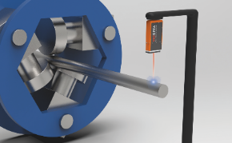
Fig. 2: A LIBS system (shown on the left) in operation for quality control at a finishing line.  File name: Secopta_PMI_2.jpg | 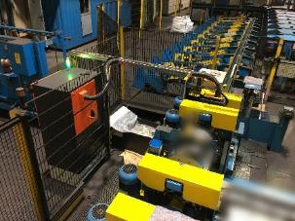
Fig. 3: The surface of the material to be analyzed is cleaned by means of an integrated high-performance ablation process.  File name: Secopta_Abbildung 3.jpg | 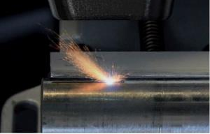

Image credits: Secopta analytics GmbH

About Secopta analytics:
Secopta analytics GmbH, based in Teltow near Berlin, offers laser-based analysis solutions for tasks in industrial process control as well as in the production of primary and secondary raw materials.
Application fields for the company’s systems range from extraction and refinement of raw materials to process control in industrial manufacturing to processing of secondary raw materials, environmental analytics and detection of hazardous substances. Secopta provides full-line customized solutions for the automation of analytical processes, including in-line, on-site and in-situ analyses during running production.

