Press Facts
Descaling of forgings
Microline descaling at Musashi Europe
Neunkirchen/Germany, June 16, 2020 SGGT Hydraulik is currently installing a new Microline Descaling MD1500 D descaling system in the Bockenau/Germany plant of Musashi Europe GmbH for descaling of large-format, rotationally symmetrical forgings for cars and trucks.
The system works with a maximum water quantity of 1.5 l per part and thus achieves a temperature drop of only 10 °C even with small parts.
In combination with innovative conveyor and control technology, which takes over the entire process handling including the press quiver feeding, it descales up to 1,200 parts per hour.
Since the process pressure in the water circuit is only generated when it is needed, the system is exceptionally high in energy efficiency: With a drive power of just 22 kW, the hydraulic power compares to 115 kW.
The process water is recirculated in a closed circuit, taking care for scale separation, its disposal and filtration. A special feature, developed for the Microline Descaling, is the physical separation of process water and ultra-fine scale with particle sizes of less than 5 µm, which cannot be adequately separated by conventional filtration technology,
The system is currently being installed between the induction heater and the new „MT 5000"; eccentric forging press and is expected to start up operations in summer 2020.
220 words including introduction
Contact:  SGGT Hydraulik GmbH  Gregor Przybylla  Betzenhölle 24  66538 Neunkirchen/Germany  Tel.: +49.6821.92083-20  www.sggt-wh.de  gregor.przybylla@sggt-wh.de | Contact for the editors:  VIP Kommunikation  Dr.-Ing. Uwe Stein  Dennewartstraße 25-27  52068 Aachen/Germany  Tel: +49.241.89468-55  www.vip-kommunikation.de  stein@vip-kommunikation.de

Figure

Fig. 1: The precomissioned machine shortly before dispatch to the customer  Filename: SGGT_microline.jpg | 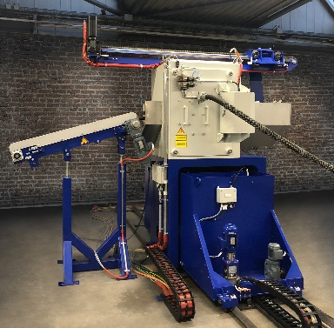
Image credits: SGGT Hydraulik GmbH

About SGGT Hydraulik
SGGT Hydraulik GmbH based in Neunkirchen/Saar, offers system technology and service for descaling and water hydraulics. SGGT equipment is used in the hot forming of metals wherever high pressure is required, often in combination with high flow rates; for example in the steel industry for descaling of slabs, billets and hot strip. The systems are experiencing an increasing demand in the forging industry and in particular in applications where hydraulic descaling was previously not common. The company's customers include renowned forges worldwide. SGGT supplies to many customers directly, and in addition, world-renowned plant engineering companies incorporate SGGT systems in their modern lines.

