Press Facts
Machines for mining and tunnelling

TML Group: Scaling at 15 m height
First-time application in mining: The UNIDACHS 850 minimizes the effort required for building up ramps.
Monheim, Germany, 18th November 2021 In September, TML put a UNIDACHS 850 scaler into operation at Barbara Erzbergbau GmbH in Porta Westfalica, Germany. The crawler machine reaches a scaling height of 15 m from the ground and thus significantly reduces the effort required for building up and removing ramps.
In the Wohlverwahrt-Nammen mine of Barbara Erzbergbau GmbH in Porta Westfalica, iron ore is extracted using drilling and blasting processes. Due to the scaling heights of up to 23 m, ramps had to be built up to remove the roof, because the existing machines could not always reach the ridge and crown area.
The new UNIDACHS 850 mining machine has been working there since September 2021. With its 12 m long telescopic boom, it reaches a considerable scaling height of 15 m from the ground: The previously necessary filling and removal of ramps has been significantly reduced! For Barbara Erzbergbau GmbH, the UNIDACHS enables significant time savings when scaling and thus financial savings.
The UNIDACHS 850 is ideally equipped for the special requirements of the Barbara Erzbergbau GmbH mine:
- two hydraulic breakers of different weights
- the FOPS (Falling Object Protective Structure) protected, 30 ° tiltable driver's cab with a roof window made of armoured glass for a better view of the ridge area
- the LED lighting package for underground use for ideal illumination of the work area
- The 270° Bird-view camera system for an optimal view when manoeuvring and the highest level of safety for personnel in the area
- a dust filtration system for the driver's cab
- a fire extinguishing system that automatically triggers in the event of a fire - for example in the engine compartment
Florian Garbe, Technical Director at Barbara Erzbergbau GmbH, Porta Westfalica: „We have been working with TML machines since 1997. Based on our positive experience over the years, we got in touch with our contact person in Monheim when it became necessary to safely scale at great heights. Our choice was made due to the reach and kinematics of the UNIDACHS with its telescopic rotary boom that are clearly superior to conventional tunnel excavators.“
Thorsten Bolender, Sales Manager Tunnel & Mining at TML, sees great benefits for his customers in the ore mining industry: “With its large reach and its infinitely 360° rotatable boom, the UNIDACHS 850 has already proven itself many times in tunnel construction. We are now using it for the first time in mining. There, too, the special kinematics facilitate and accelerate linear scaling of the roof, the sidewalls and the face. At the same time, scaling from just one standing position contributes significantly to underground safety.“
430 words including introduction
The technology in detail:
The mobile machines and scalers of the UNIDACHS series cover a wide range of applications from the compact 3.2 t UNIDACHS 110 to the 45 t UNIDACHS 850. A key feature of the UNIDACHS is their telescopic boom that can rotate endlessly by 360°. The telescopic function enables a precise linear scaling operation and the access to scaling areas that cannot be reached by tunnel excavators. Beside caterpillar tracks, many models are optionally available with all-wheel-drive tire mounted undercarriages with outriggers for additional stability.
In general, TML adapts its machines to the specific local requirements in mining and tunnelling: For example, the hydraulic hoses and the telescopic cylinder are safely located inside the boom. The boom’s robust and closed steel housing protects the inner components from dirt and from being damaged by loose rock falling on the boom during operation. This design not only increases the availability of the machine, it also reduces the risk of a hydraulic oil leakage to almost zero.
In addition, TML offers protection rails for the superstructure, deflector plates in the front area of the main boom and dirt deflectors between the main boom and telescopic arm.
In mining and tunnelling, the UNIDACHS is particularly suitable for excavating caverns, producing cross-passages, profiling tunnel cross-sections and scaling with a hydraulic hammer, cutter, ripper hook or ripper bucket. It can accommodate drilling unit attachments as well as tools for placing arches and anchors. Furthermore, the 360° rotatable boom in combination with shotcrete nozzles adds to the high level of versatility of the UNIDACHS.
The technology in detail: 250 words
About TML
Since 1993, TML Technik GmbH is developing and manufacturing mobile machines with 360° rotatable and telescopic booms for the iron and steel industry, mining and tunnelling, and the demolition and construction industries. Hundreds of machines supplied by TML, individually tailored to deal with challenging operating conditions, are constantly proving their value in the harshest of conditions in more than 80 countries.
At its headquarters at Monheim am Rhein/Germany – centrally located between Dusseldorf and Cologne – the company develops and designs the machines, and manufactures them in six factory buildings, covering an area of 22,000 m²: “Made in Germany”.
With over 100 employees and with its branches and agencies, the company maintains a global presence and, in addition to on-site commissioning, offers quick availability for maintenance and repair as well as worldwide spare parts service.
Contact:  TML Technik GmbH  Thorsten Bolender  Daimlerstraße 14 - 16  40789 Monheim/Germany  Tel.: +49 2173 9575-202  www.tml.de  E-Mail: t.bolender@tml.de | Counterpart for the editors:  VIP Kommunikation  Dr.-Ing. Uwe Stein  Dennewartstraße 25 - 27  52068 Aachen/Germany  Tel.: +49 241 89468-55  www.vip-kommunikation.de  E-Mail: stein@vip-kommunikation.de

Photos:

Download of high resolution photos: press photos TMLTechnik
Fig. 1: Up to 15 m scaling height … easily accessible from the ground by the UNIDACHS 850.  File name: TML-AW57295.jpg | 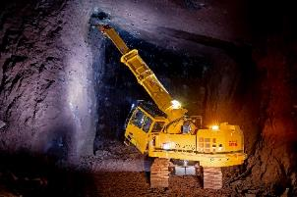
Fig. 2: 30° tiltable operator cab for optimal view to the roof scaling area.  File name: TML-AW57394.jpg | 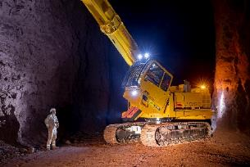
Fig. 3: The 270° Bird-view cameras put an end to blind spots around the machine.  File name: TML-Birdview.jpg | 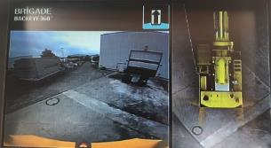
Fig. 4: The UNIDACHS 850 shortly before delivery to Barbara Erzbergbau GmbH  File name: TML-AW53334.jpg | 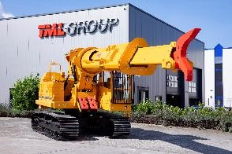
Image credits: TML Technik GmbH

