Press facts for bauma 2022
Telescopic arm machines for mining and tunnelling as well as for the demolition and construction industry

Premiere at bauma 2022:
Remotely controlled machine with 360° rotary telescopic arm for working in confined spaces
Working safely in places standard hydraulic excavators cannot reach.
Monheim/Germany, 25 July 2022 For the first time TML will present at bauma the new, fully remotely controlled mobile machine UNIDACHS 430RK. Thanks to the special kinematics of its 360° endlessly rotating telescopic boom and its compact dimensions, the machine makes it possible to work in confined spaces or in areas with difficult access. The operator works at a safe distance using the radio remote control.
TML developed the new UNIDACHS 430RK for job sites where the available space, surrounding structures or dangerous conditions make work difficult. The "RK" in the product name stands for "Remote" and "Knickgelenk" (articulated joint): all the machine's functions are remotely controlled, the additional cradle mount for the telescopic boom makes it possible to work over a particularly large working area even in a confined space.
This new degree of freedom makes the UNIDACHS 430RK combined with the proven, 360° rotary telescopic arm into a machine of universal application for the removal or application of material, or for machining surfaces. The attachments – for example pneumatic or hydraulic hammers, ripper tips, rotary drum cutters as well as various types of excavator bucket – can be moved in up to five axes simultaneously. They can be used, for instance, in the roof and side wall areas, underneath the machine or in confined spaces, at almost any angle – and that from only one location.
Typical applications are profiling tunnel cross-sections, the excavation of caverns and galleries, the precise linear scaling of roofs and walls in mines and tunnels. The telescopic arm can also be fitted, for instance, with spray nozzles for liquid concrete as well as drilling attachments and tools for setting arches and anchors.
Thorsten Bolender, Sales Manager Tunnel & Mining at TML, emphasises: "With the compact design and its unique kinematics, the new UNIDACHS 430RK makes it possible to work safely in places that standard hydraulic excavators cannot reach. The telescopic arm covers a vertical slewing range of +45° to -108°; with a telescopic stroke of 3,000 mm the attachment reaches heights of more than 10 m. At the same time, the telescopic arm provides a torque of 14.8 kNm as well as a maximum breakout force of 73 kN."
Unique: the compact UNIDACHS 110
At bauma 2022, TML will exhibit the particularly compact machine UNIDACHS 110 also with the 360° endlessly rotating boom arm. Application areas and configuration variants are similar to those of the UNIDACHS 430RK, however, the machine is significantly more compact.
With its small dimensions – the chassis is only 1,315 mm wide, 1,644 mm high – it is suitable for work in particularly confined spaces. Nevertheless, the machine has a large working area: the boom has a reach of up to 5,000 mm, depending on the length of the attachment. As such the UNIDACHS can reach the complete profile of a service passage, adit or tunnel from one location and therefore all areas in which material is to be removed, worked or applied.
Thorsten Bolender sees not only technical but also commercial advantages: "The UNIDACHS 110 is the only machine for mining and tunnelling available on the market that is extremely compact and at the same time offers all the advantages of the rotating boom arm. These features open up completely new optimisation potential in mining and tunnelling for our customers: they can now work cost-effectively even in extremely confined spaces."
560 words including leader and spaces
The technology in detail:
The mobile machines and scaling equipment in the UNIDACHS series cover a wide range of applications from the compact 3.2 t UNIDACHS 110 to the 45 t UNIDACHS 850. Like the UNIDACHS 110, all other UNIDACHS models have a boom arm that can be endlessly rotated by 360° and also have the telescopic function of the boom. Four models are optionally available with tracked crawler or wheeled crawler with all-wheel-drive.
With comprehensive configuration packages, TML adapts every UNIDACHS to the project-specific requirements: in tunnelling, in mining or for demolition. Equipment includes electrical or diesel drive, FOPS-protected upper cab, automatic central lubrication system, dust protection system, LED lighting packages, camera options from the reversing camera to a 270° bird view system, radio remote control, as well as numerous different attachments.
The completely enclosed and shielded boom protects the telescopic cylinders and hydraulic hoses inside against the ingress of dust or rock and in this way ensures the highest possible reliability.
TML Technik at bauma 2022
Messe München/Germany
24 to 30 October 2022:
Stand C5.324
About TML
Since 1993 TML Technik GmbH has developed and manufactured mobile machines with 360° rotary and telescopic booms for the iron and steel, mining and tunnelling, demolition and construction industry. Hundreds of delivered machines, individually tailored to challenging operating conditions, prove themselves day after day in more than 80 countries in the harshest ambient conditions.
At its headquarters in Monheim am Rhein – centrally located between Düsseldorf and Cologne – the organisation designs the machines and manufactures them with more than 60 years of know-how over 22,000 m² of floorspace in six modern factory buildings: "Made in Germany".
With more than 100 employees as well as subsidiaries and representatives, TML Technik GmbH is present worldwide and also provides the necessary customer support after the delivery and commissioning of a machine.
Contact:  TML Technik GmbH  Thorsten Bolender  Daimlerstrasse 14 - 16  40789 Monheim  Tel.: +49.2173.9575-202  Fax: +49 2173-9575 400  www.tml.de  E-mail: t.bolender@tml.de | Contact person for the press:  VIP Communication  Dr.-Ing. Uwe Stein  Dennewartstrasse 25 - 27  52068 Aachen  Tel.: +49.241.89468-55  www.vip-kommunikation.de  E-mail: stein@vip-kommunikation.de

Images:

High resolution image file download:

Download Text + Photos
Figure 1: The telescopic arm on the new, remotely controlled UNIDACHS 430RK covers a vertical slewing range of +45° to -108°; with a telescopic stroke of 3,000 mm the attachment reaches heights of more than 10 m.  File name:  TML_IMG_5064.jpg | 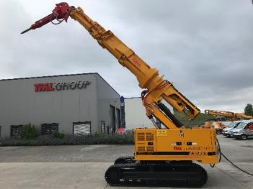
Figure 2: The boom on the UNIDACHS 110 has a reach of up to 5,000 mm. As such the UNIDACHS can reach the complete profile of a service passage, adit or tunnel.  File name:  TML_Unidachs_110_Tunnel1.jpg | 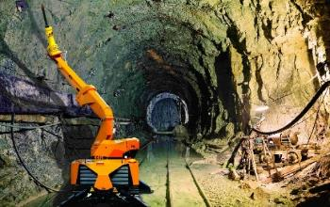
Figure 3: The UNIDACHS 110 operator works at a safe distance using the remote control.  File name:  TML UNIDACHS 110 im Einsatz.jpg | 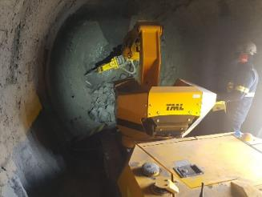
Figure 4: The "big brother" of the UNIDACHS 110, the UNIDACHS 220, has a telescopic boom arm and is even more flexible in use.  File name:  TML-Unidachs-220-AW57318.jpg | 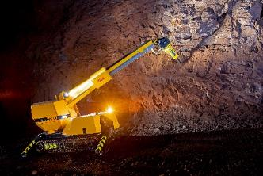
Figure 5: The UNIDACHS 110 is controlled from a safe distance during demolition work.  File name:  TML_Unidachs_110_Abbruch.jpg | 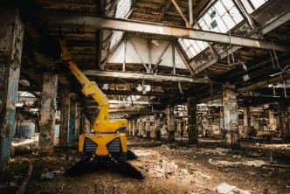
Image credits: Factory photographs, TML Technik GmbH

