Press Facts for STUVA-Expo 2021
Mobile machines for mining and tunnelling

Premiere at STUVA-Expo:
UNIDACHS 110 – unique kinematics offer high flexibility when working in confined spaces
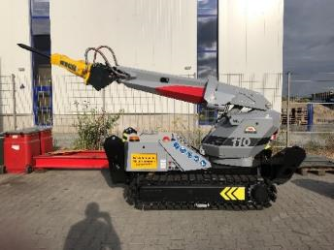
360° rotatable cantilever arm opens up new possibilities
Monheim, Germany, October 29, 2021 Launching at STUVA-Expo 2021, TML is showing the new mobile machine UNIDACHS 110, which the company has developed especially for mining and tunnel construction as a manipulator for a diverse range of attachments. The very compact machine is particularly suitable for use in confined spaces at locations that cannot be reached by standard hydraulic excavators or demolition robots.
With its 360° endlessly rotatable cantilever boom, the UNIDACHS 110 has an additional degree of freedom compared to articulated-arm excavators or demolition robots. It enables working tools - for example rotary drum cutters, hydraulic hammers, shears, pulverisers or shovels - to be utilised at almost any required angle of the profile or surface to be worked on.
Due to its compact design, it is particularly suitable for use in tunnel or adit construction, in the renovation and expansion of tunnels, in mining or in the demolition or dismantling of structures. Typical areas of application are working the surface, excavating caverns, producing cross-passages, profiling tunnel cross-sections, scaling with an hydraulic hammer or cutter and clearing, using different types of shovels. Furthermore, it can accommodate shotcrete nozzles as well as tools for placing arches and anchors.
Furthermore, the new UNIDACHS 110 is characterized by its compact design, high maneuverability and strong hydraulic drive. The width of the undercarriage is only 1,315 mm, its overall height is 1,644 mm. Despite its compact size, the machine has a large working radius of up to 5,000 mm, depending on the length of the attachment. In this way, the UNIDACHS can reach the complete profile of a supply corridor, adit or tunnel and thus all areas in which material is to be removed, processed or applied from just one standing position.
Thorsten Bolender, Sales Manager Tunnel & Mining at TML, sees not only technical advantages, but also economic ones: "The special kinematics of the UNIDACHS make it possible, among other things, to follow the surface contour very precisely with the attachment tool. This saves a lot of time, for example when profiling cross-sections, working in the roof and sidewall areas or performing scaling works. And the extreme compactness of the machine is another factor: This opens up completely new optimization potential in mining and tunnelling. "
400 words
The technology in detail
The mobile machines and scalers of the UNIDACHS series cover a wide range of applications from the compact 3.2 t UNIDACHS 110 to the 45 t UNIDACHS 850. Like the UNIDACHS 110, all other UNIDACHS models have a boom that can rotate endlessly by 360 °, but are additionally equipped with a telescopic function of the boom for a longer reach. Beside caterpillar tracks, many models are optionally available with all-wheel-drive tire mounted undercarriages with outriggers for additional stability.
With extensive equipment variants, TML adapts every UNIDACHS to the project-specific requirements in tunnel construction: These include electric or diesel drive, the FOPS-protected operator cabin, the automatic central lubrication system, the air particulate filtration system, the LED lighting package, camera options from reversing camera to 270 ° bird view systems, radio remote controls, as well as a large number of different attachment tools.
The completely closed and shielded boom protects the internal telescopic cylinders and hydraulic hoses against the ingress of dust and rock and thus guarantees the highest level of reliability.

The technology in detail: 170 words
TML Technik at STUVA-Expo 2021
Messe Karlsruhe, Germany
24. - 25. November 2021:
hall 1 – stand A147
About TML
Since 1993, TML Technik GmbH is developing and manufacturing mobile machines with 360 ° rotatable and telescopic booms for the iron and steel industry, mining and tunnelling, and the demolition and construction industries. Hundreds of machines supplied by TML, individually tailored to deal with challenging operating conditions, are constantly proving their value in the harshest of conditions in more than 80 countries.
At its headquarters at Monheim am Rhein/Germany – centrally located between Dusseldorf and Cologne – the company develops and designs the machines, and manufactures them in six factory buildings, covering an area of 22,000 m²: “Made in Germany”.
With over 100 employees and with its branches and agencies, the company maintains a global presence and, in addition to on-site commissioning, offers quick availability for maintenance and repair as well as worldwide spare parts servic..

Contact:  TML Technik GmbH  Thorsten Bolender  Daimlerstraße 14 - 16  40789 Monheim, Germany  Tel.: +49 2173 9575-202  www.tml.de  E-Mail: t.bolender@tml.de | Press contact  VIP Kommunikation  Dr.-Ing. Uwe Stein  Dennewartstraße 25-27  52068 Aachen, Germany  Tel.: +49 241 89468-55  www.vip-kommunikation.de  E-Mail: stein@vip-kommunikation.de

Photos:

Download of high quality images: press photos TML
Image 1: The UNIDACHS 110 is of more compact design than its „big brother“ of the same series.  Dateiname:  TML_Unidachs_110_3.jpg | 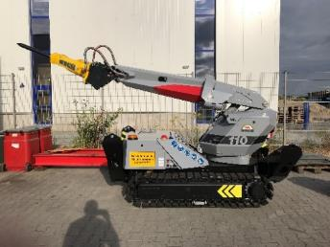
Image 2: The radio remote controls allow the operator to work at a safe distance  Dateiname:  TML Unidachs_110_Test_TML (4).jpg | 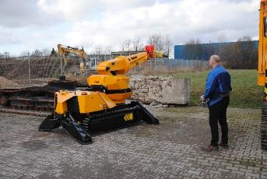
Image 3: With the 360° boom rotation, the machine has an additional degree of motion compared to standard articulated boom machines.  Dateiname:  TML Unidachs_110_Test_TML (25).jpg | 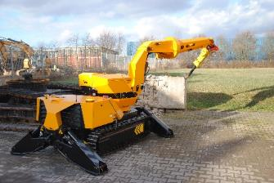
Image 4: The „big brother“ of the UNIDACHS 110, the UNIDACHS 220, additionally has a telescopic boom function and can therefore be used even more flexibly.  Dateiname:  TML_Unidachs_220_AW57318.jpg | 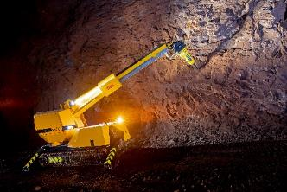
Images: TML Technik GmbH

