Press Facts for the Metec 2023
Cold rolling of strips and foils
Vollmer: Measuring systems for shape and thickness with extended connectivity and higher accuracy
Hagen, Germany, March 24, 2023 At the METEC, Vollmer will be showing two innovations for the cold rolling of strips: The BFI roller for shape measurement now has a web-based evaluation system which simplifies integration into the rolling process. Furthermore, the company now supplies the laser-based thickness gauges of the VTLG series in versions for strip widths up to 1,480 mm and for thin foils.
Shape measurement with the digital BFI roller
For the measurement of the strip shape, Vollmer has digitalised the interface of the BFI roller. Communication with the mill process control system is via TCP/IP. Parameterisation of the software and the display in the new graphic design are completely web-based. Every device with a web browser in the same network as the shape computer – be it a PC, notebook, tablet or smartphone – can display the measurement data.
With individually manufactured diameters of between 200 and 600 mm, the BFI roller that Vollmer manufactures under the patent of the VDeH-Betriebsforschungsinstitut (BFI) can be integrated into practically any mill stand instead of deflector rolls. The outer surface of the roll body is absolutely homogeneous and can be reground on all standard roll grinding machines. The width of the measuring zones can be freely selected above 17 mm.
Laser-based thickness measurement with VTLG
Vollmer now supplies the VTLG thickness gauges with a measurement throat depth of up to 1,480 mm so that they can record transverse thickness profiles even on wide strips. The new systems work with the same high measuring resolution of 0.1 µm as the smaller ones used on narrower strips. Also new is the VTLG 1420/20 for measuring on strips up to 20 mm thick; with an air gap of 215 mm, they measure with an accuracy of +/- 5 µm.
Vollmer will also be presenting the VTLG 101/1 at the fair. It has been specially designed for the cold-rolling of foils with thicknesses between 0.003 and 2.0 mm, and is the only laser measuring system available on the market that can be installed in the immediate vicinity of the roll gap even when rolling foils. It operates with an absolute measuring precision of +/- 0,5 µm.
360 words

Vollmer at the Metec 2023
Düsseldorf, 12 to 16 June 2023
Hall 4 / Stand D18
Contact:  Friedrich Vollmer Feinmessgerätebau GmbH  Dipl.-Ing. Elke Roller  Verbandsstraße 60 b  58093 Hagen, Germany  Tel.: +49.2334.507-190  www.vollmergmbh.de  E-mail: elke.roller@vollmergmbh.de | Press contact:  VIP Kommunikation  Die Content-Agentur für Technik-Themen  Dr.-Ing. Uwe Stein  Dennewartstraße 25- 27  52068 Aachen, Germany  Tel.: +49.241.89468-55  www.vip-kommunikation.de  stein@vip-kommunikation.de
Figures
Download the high-resolution image files: press photos Vollmer

Figure 1: Vollmer is presenting the BFI roller in a digital version at the fair.  File name:  Vollmer_BFI_Rolle_1_8.jpg | 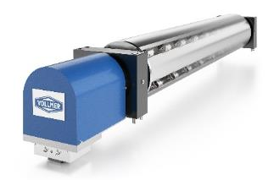
Figure 2: The VTLG 101/1 for laser-based thickness measurement on foils with thicknesses between 0.003 and 2.0 mm is so compact that it can be installed in the immediate vicinity of the roll gap.  File name:  Vollmer_VTLG_39.jpg | 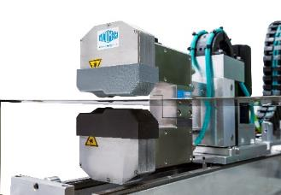
Photo copyrights: Vollmer works photos
About Friedrich Vollmer Feinmessgeräte GmbH
The development in 1963 of the world's first strip thickness gauge that was able to measure the thickness of strips with an accuracy of a few µm during rolling in the cold stand marked the start of the company history. Vollmer was also one of the first companies to enable shape measurement on the passing strip.
Over the course of the years, Vollmer has developed various contact gauges as well as isotope and X-ray systems for thickness measurement on strip, shape measuring systems and roll measuring gauges. Today more than 2,500 strip thickness gauges and over 100 shape measuring systems are installed in mills worldwide. Vollmer has also equipped more than 100 roll grinding machines with roll measuring gauges. The modernisation of mills, including the changeover to hydraulic screwdowns and the installation of systems for gauge control (AGC) and flatness control (AFC) of strip round out the portfolio.
Vollmer has around 85 employees at its headquarters in Hagen. Partners and subsidiaries in more than 30 countries are available to support the customer and provide quick on-the-spot service.

