Facts for the trade press
Sustainable abrasives for surface finishing
VULKAN INOX
Energy-efficient production reduces user's carbon footprint and abrasive consumption
Reusable stainless steel blasting media increase sustainability and improve the eco-balance.

Hattingen/Germany, April 21, 2023 At GIFA 2023, VULKAN INOX will showcase CHRONITAL and GRITTAL blasting abrasives, which the company has been producing exclusively with renewable energy since 2022. By doing so, VULKAN INOX improves the eco-balance of its customers, because the blasting media they purchase brings a significantly smaller CO₂ footprint. In addition, the reusable stainless steel blasting abrasives reduce consumption to just a few percent compared with mineral-based ones. Thus, when blasting metal workpieces, they make a significant contribution to the sustainability of production.
VULKAN INOX is the first manufacturer to supply stainless steel blasting abrasives that are both produced and used in a particularly environmentally friendly manner and are reusable: They are made from melted steel scrap and are completely recycled back into the metal cycle - a prime example of functioning recycling management.
Since last year, VULKAN INOX has been using 100 percent regenerative electrical energy for its induction furnaces. As a result, the blasting media leaves the plant in Hattingen with an outstandingly small CO₂ footprint. When used by customers it significantly improves the eco-balance, because they wear very slowly on impact with the workpieces and cycle again and again in a closed circuit. VULKAN’s blasting media reduces the amount of abrasives used to just a few percent of the quantities previously required compared with mineral materials.
The high dimensional stability of the individual stainless steel grains prevents the formation of dust and noticeably improves working and visibility conditions. In addition, their use reduces the amount of waste and the cost of disposal.
Christian Hoffmann, Sales Manager at VULKAN INOX, knows that his customers are making great efforts to reduce their own footprint. Once again, he sees VULKAN INOX as a pioneer in its industry: "We have made many adjustments: As a starting material, we deliberately buy secondary input materials with a low CO₂ footprint . Since 2022, we have been operating our induction furnaces with electricity generated from renewable sources and implementing waste heat recovery to power the drying process. Overall, we have reduced CO₂ emissions from our own and third-party energy sources (Scope 1 and 2) by 87 percent since 2018. This means we are conserving valuable resources. Our goal is to convert the entire process so that gas will no longer be required.“
380 words including introduction
Vulkan Inox VULKAN INOX at GIFA 2023
Düsseldorf/Germany, June 12 to 16, 2023
Hall 16 / Stand G 09
Contact:  VULKAN INOX GmbH  Christian Hoffmann  Gottwaldstraße 21  45525 Hattingen/Germany  phone: +49 2324 5616-0  mobile: +49 173 588 73 68  www.vulkan-inox.de  christian.hoffmann@vulkan-inox.de | Contact for the editors:  VIP Kommunikation  Dr.-Ing. Uwe Stein  Dennewartstraße 25-27  52068 Aachen/Germany  +49 241 89468-55  www.vip-kommunikation.de  stein@vip-kommunikation.de

Figures:
Download of high resolution photos:
Please click here: press photos Vulkan Inox
Fig. 1: In the induction furnaces, stainless steel is melted and then atomized, creating the spherical CHRONITAL.  File name:  Vulkan Inox-DSC_0040K.jpg | 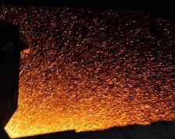
Fig. 2: The angular GRITTAL (left) and the spherical CHRONITAL in comparison.  File name:  Vulkan Inox-IMG_3544K2.jpg | 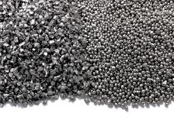
Fig. 3: CHRONITAL is mainly suitable for cleaning, deburring and edge rounding  File name:  Vulkan Inox-S-150.jpg | 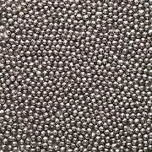
Fig. 4: The angular GRITTAL is formed by crushing the granules
File name:
Vulkan Inox-G---40.jpg
Fig. 5: Aluminum castings after blasting.  File name:  Vulkan Inox-Aluminiumguss_gestrahlt (3).jpg | 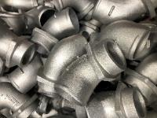
Image credits: Vulkan Inox GmbH
About VULKAN INOX
VULKAN INOX GmbH, founded in 1985, specializes in the development and production of durable, corrosion-resistant abrasives for a variety of blasting tasks in surface finishing on different metallic and mineral materials. Examples are deburring and edge rounding, desanding and descaling, roughening and structuring, smoothing and cleaning. The basis of the product range is the spherical CHRONITAL and the angular GRITTAL, which are used alone or in combination.
At the heart of production are two high-performance induction melting furnaces, which mainly melt recycled scrap. At the company headquarters in Hattingen, 63 employees work in development, production and administration. More than 30 representative offices worldwide stand for competent technical advice, reliable delivery and fast service.

